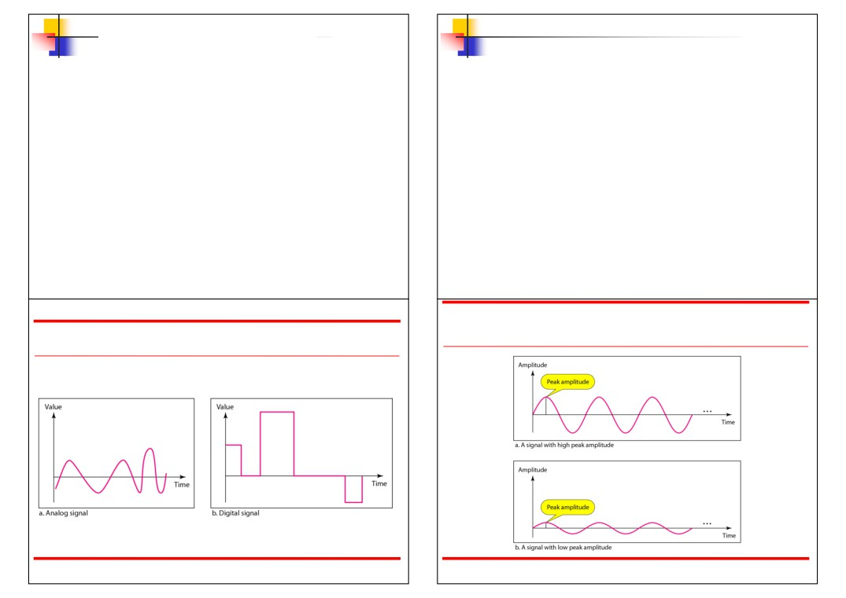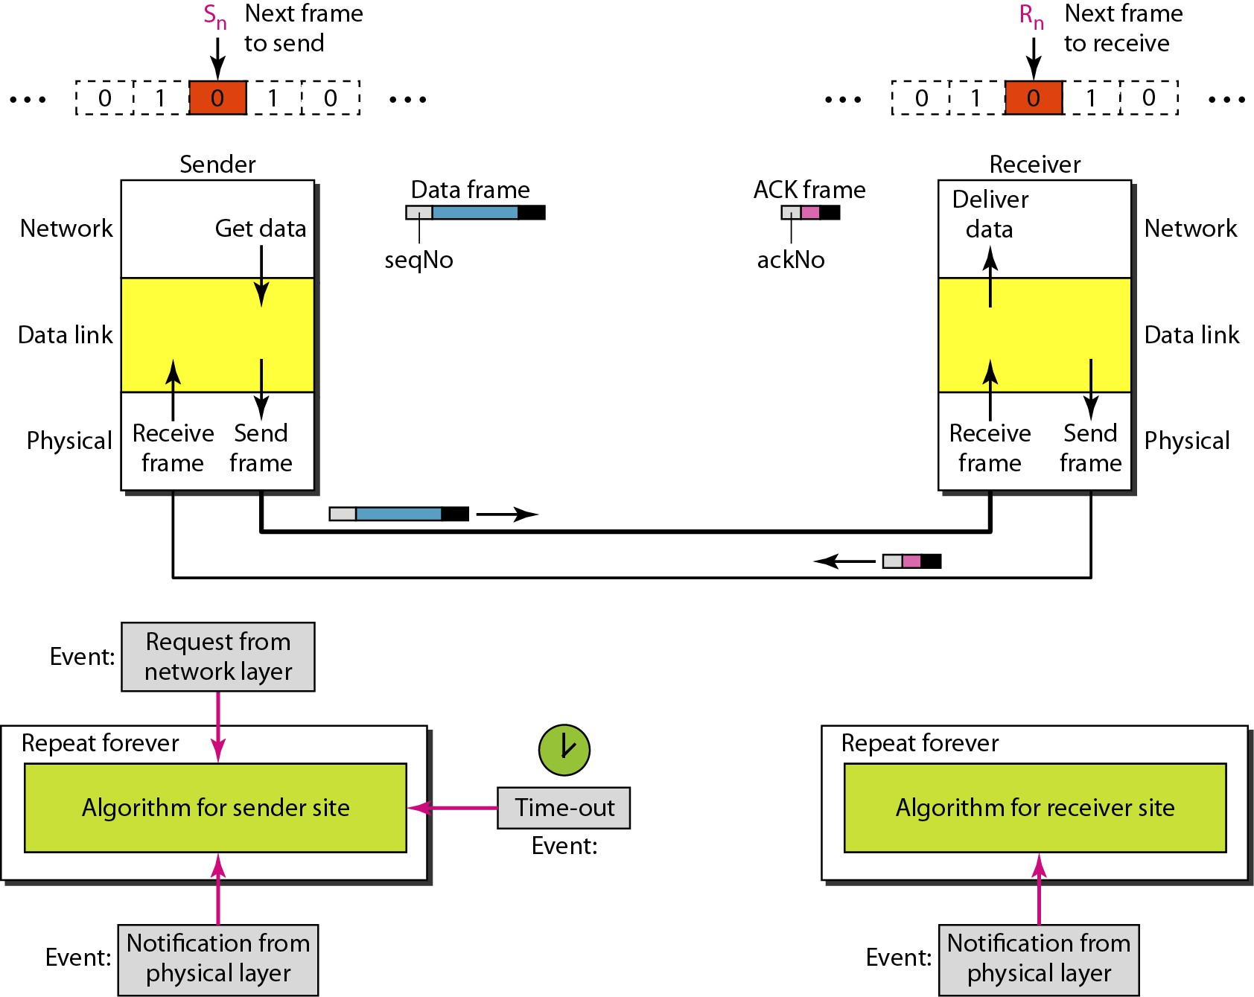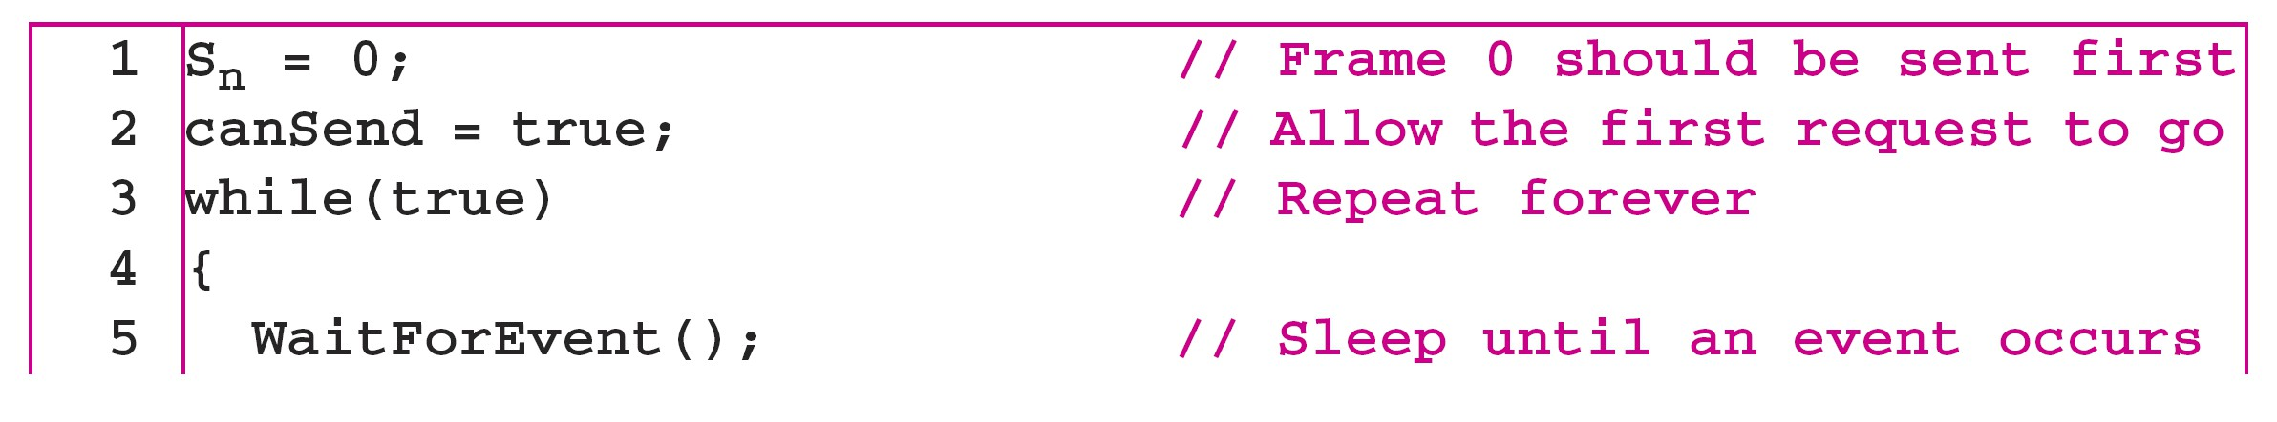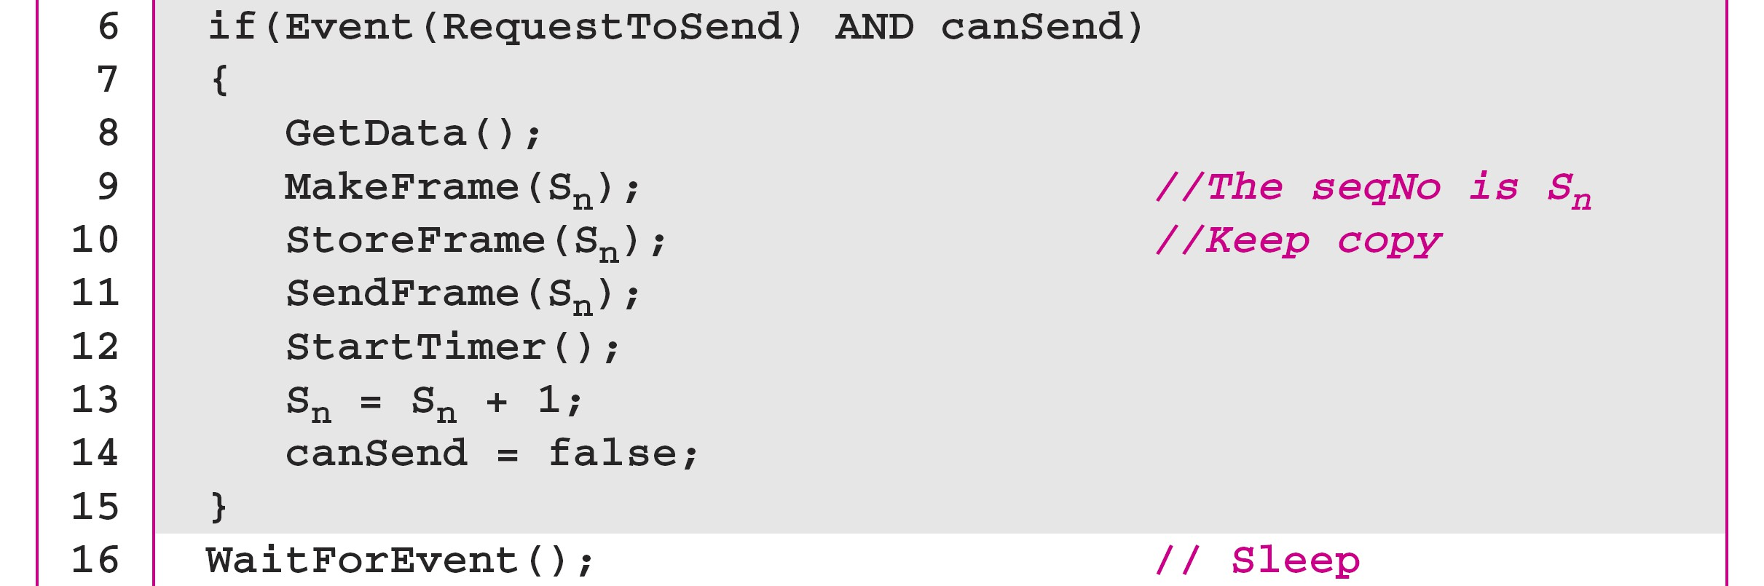

*Note*

In Stop-and-Wait ARQ, we use sequence

numbers to number the frames.

The sequence numbers are based on   
 modulo-2 arithmetic.

11.26

Figure 11.10 *Design of the Stop-and-Wait ARQ Protocol*

11.28

*Note*

In Stop-and-Wait ARQ, the   
 acknowledgment number always   
announces in modulo-2 arithmetic the

sequence number of the next frame

expected.

11.27

Algorithm 11.5 *Sender-site algorithm for Stop-and-Wait ARQ*

(continued)

11.29

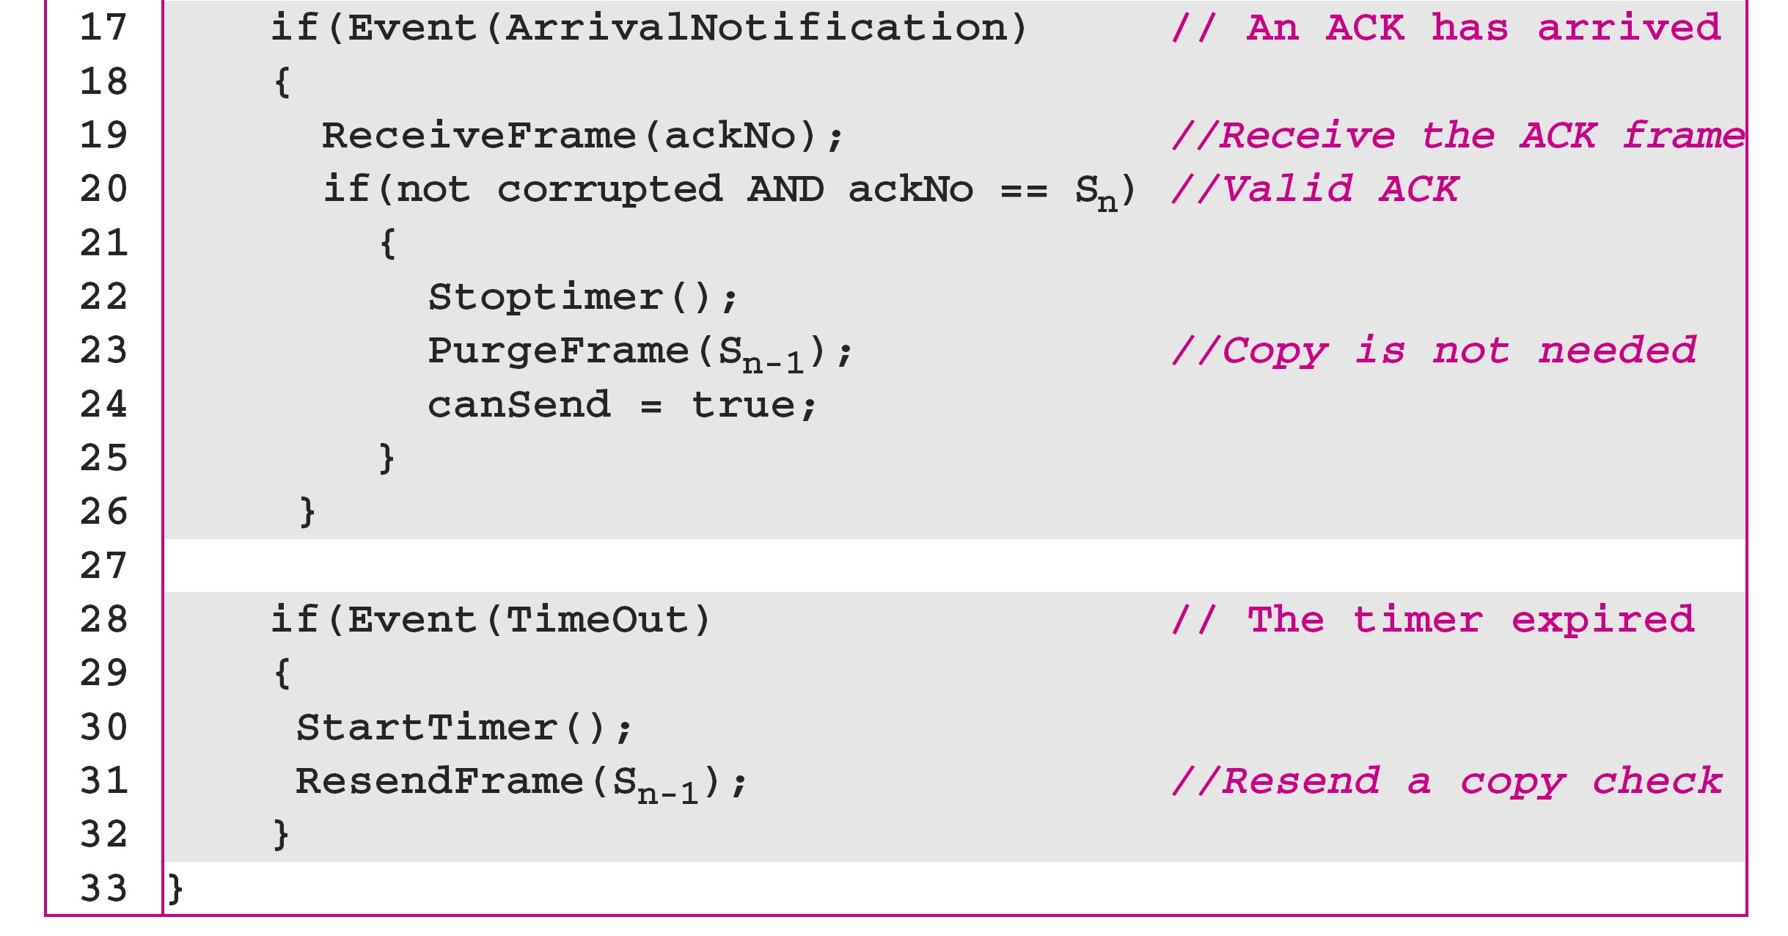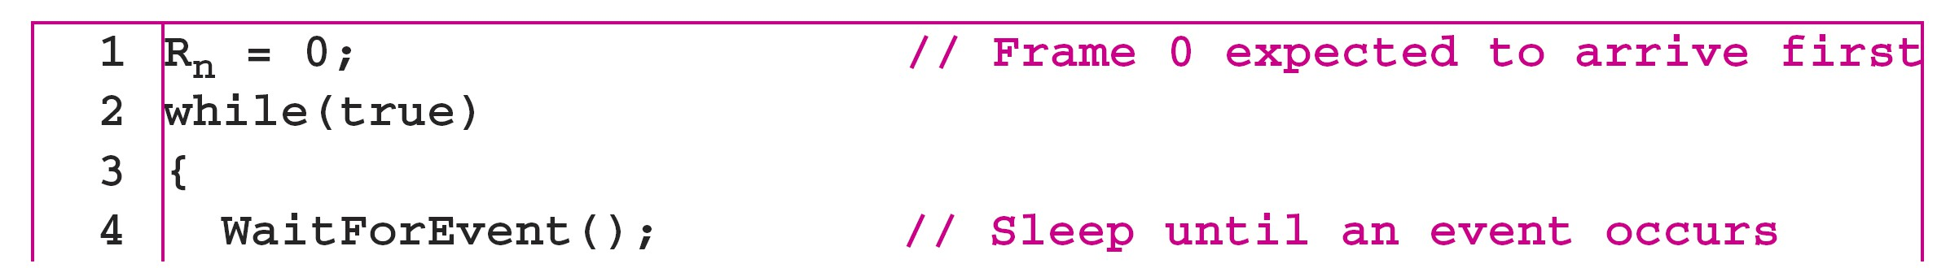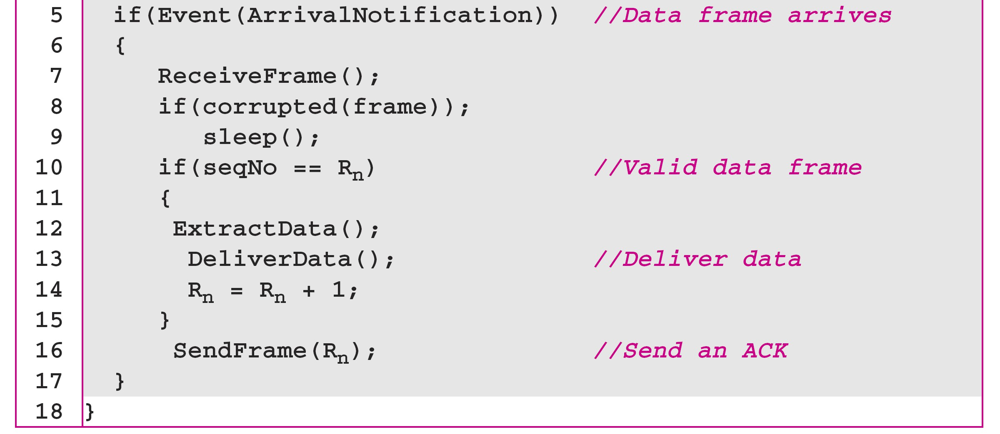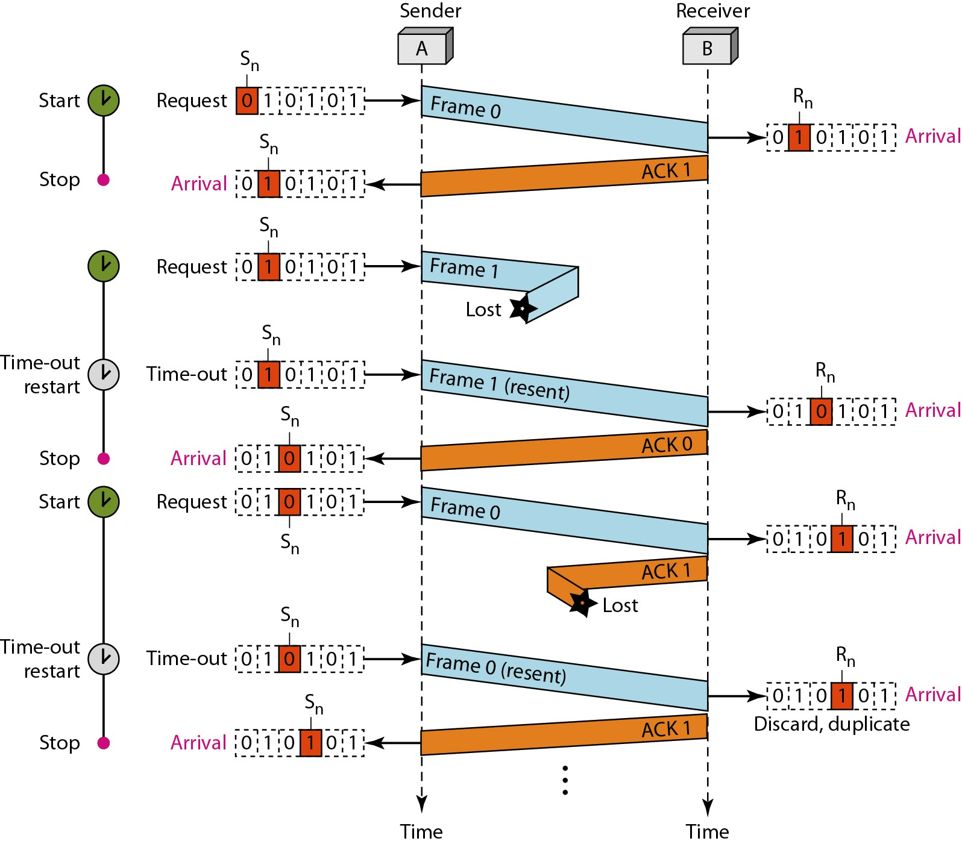

Algorithm 11.5 *Sender-site algorithm for Stop-and-Wait ARQ*  (continued)

11.30

Algorithm 11.6 *Receiver-site algorithm for Stop-and-Wait ARQ Protocol*

11.31

*Example 11.3*

Figure 11.11 *Flow diagram for Example 11.3*

*Figure 11.11 shows an example of Stop-and-Wait ARQ.*   
*Frame 0 is sent and acknowledged. Frame 1 is lost and*   
*resent after the time-out. The resent frame 1 is*   
*acknowledged and the timer stops. Frame 0 is sent and*   
*acknowledged, but the acknowledgment is lost. The*   
*sender has no idea if the frame or the acknowledgment*   
*is lost, so after the time-out, it resends frame 0, which is*   
*acknowledged.*

11.32

11.33

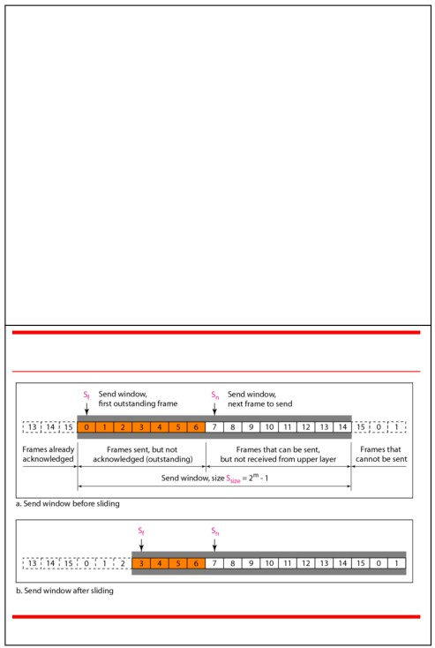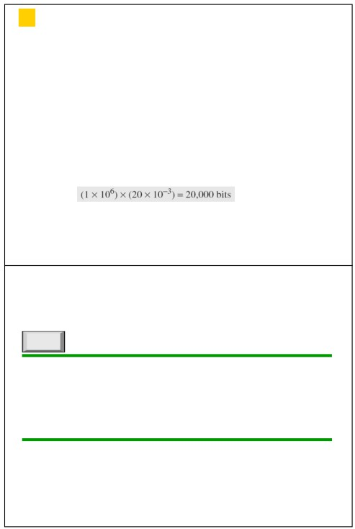

*Example 11.4*

*Assume that, in a Stop-and-Wait ARQ system, the bandwidth of the line is 1 Mbps, and 1 bit takes 20 ms to make a round trip. What is the bandwidth-delay product? If the system data frames are 1000 bits in length, what is the utilization percentage of the link?*

Solution

The bandwidth-delay product is

11.34

*Note*

In the Go-Back-N Protocol, the sequence   
 numbers are modulo 2m,

where m is the size of the sequence   
 number field in bits.

11.36

*Example 11.4 (continued)*

*The system can send 20,000 bits during the time it takes for the data to go from the sender to the receiver and then back again. However, the system sends only 1000 bits. We can say that the link utilization is only 1000/20,000, or 5 percent. For this reason, for a link with a high bandwidth or long delay, the use of Stop-and-Wait ARQ wastes the capacity of the link.*

11.35

Figure 11.12 *Send window for Go-Back-N ARQ*

11.37

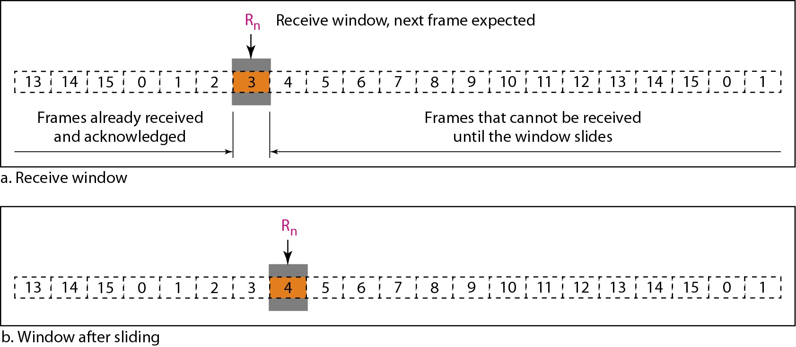

*Note* *Note*

The send window is an abstract concept The send window can slide one

defining an imaginary box of size 2m − 1 or more slots when a valid

with three variables: Sf, Sn, and Ssize. acknowledgment arrives.

11.38 11.39

Figure 11.13 *Receive window for Go-Back-N ARQ*

*Note*

The receive window is an abstract   
concept defining an imaginary box   
of size 1 with one single variable Rn.

The window slides

when a correct frame has arrived;   
sliding occurs one slot at a time.

11.40

11.41

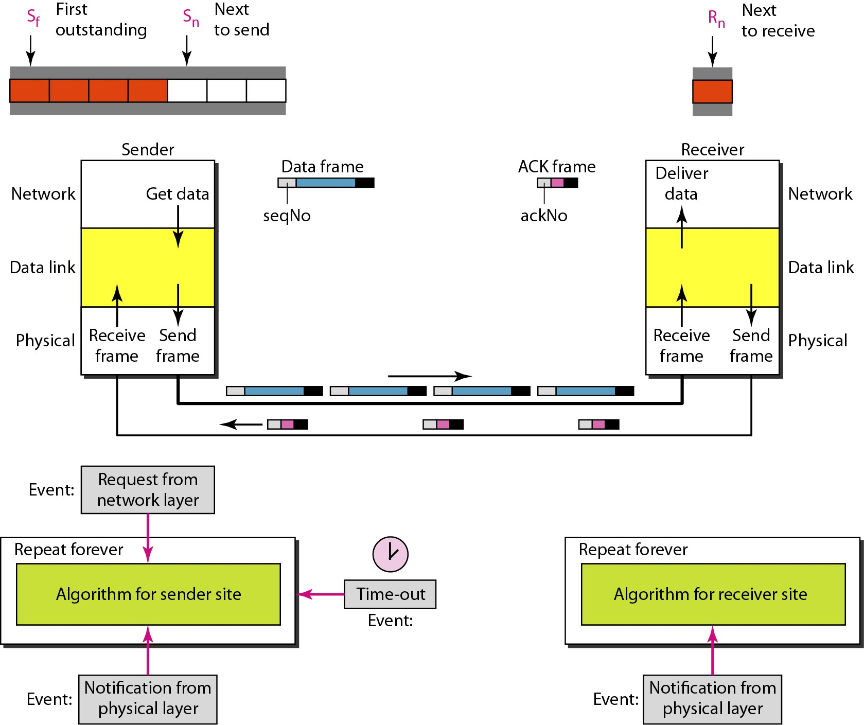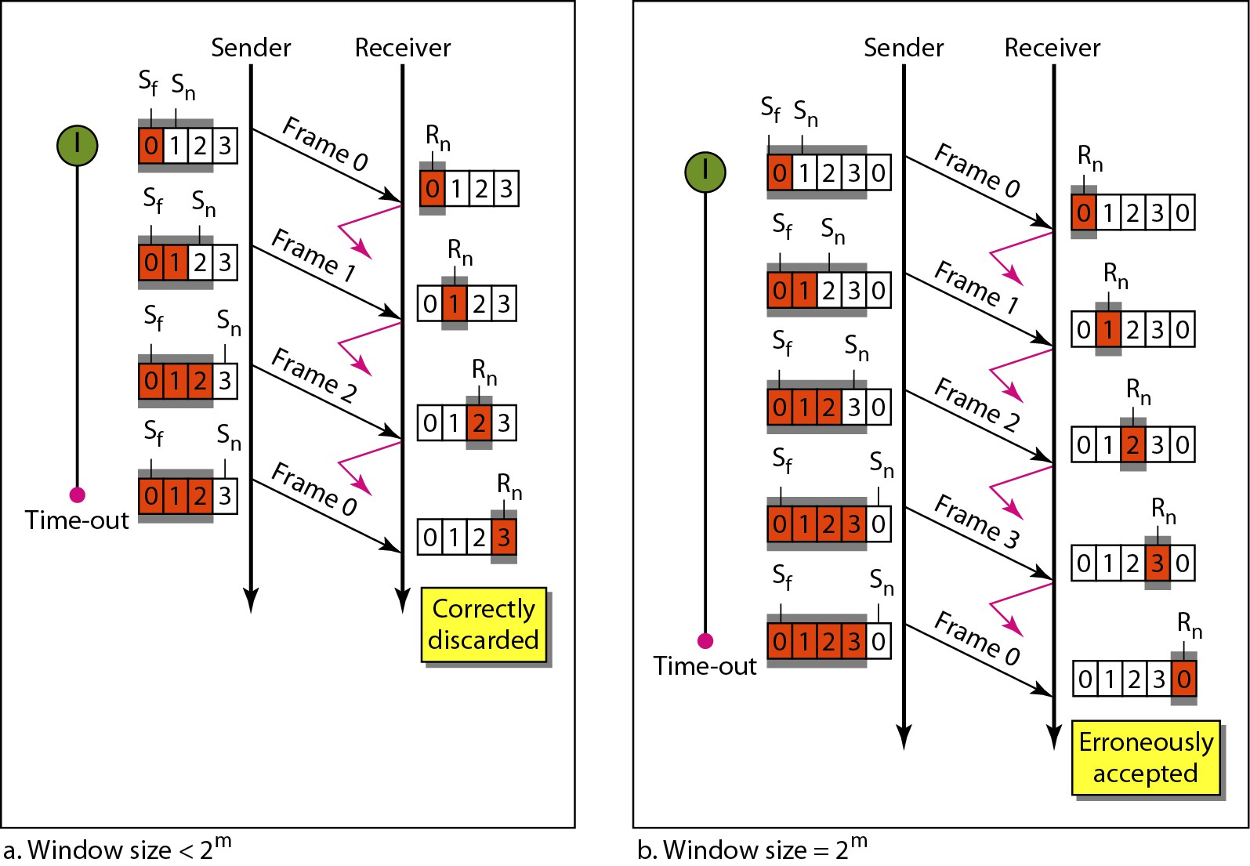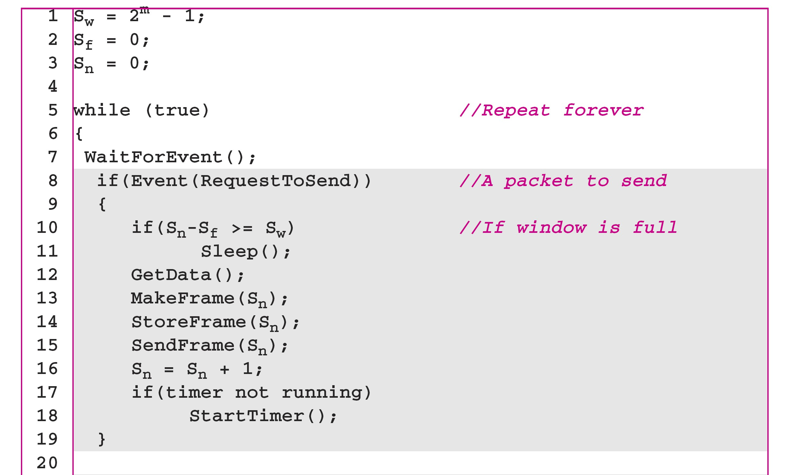

Figure 11.14 *Design of Go-Back-N ARQ*

11.42

*Note*

In Go-Back-N ARQ, the size of the send   
 window must be less than 2m;

the size of the receiver window   
 is always 1.

11.44

Figure 11.15 *Window size for Go-Back-N ARQ*

11.43

Algorithm 11.7 *Go-Back-N sender algorithm*

(continued)

11.45

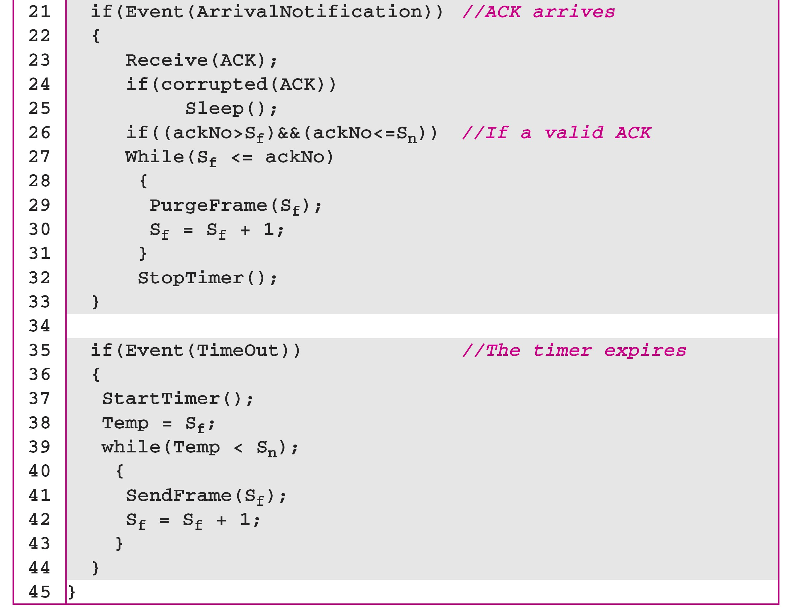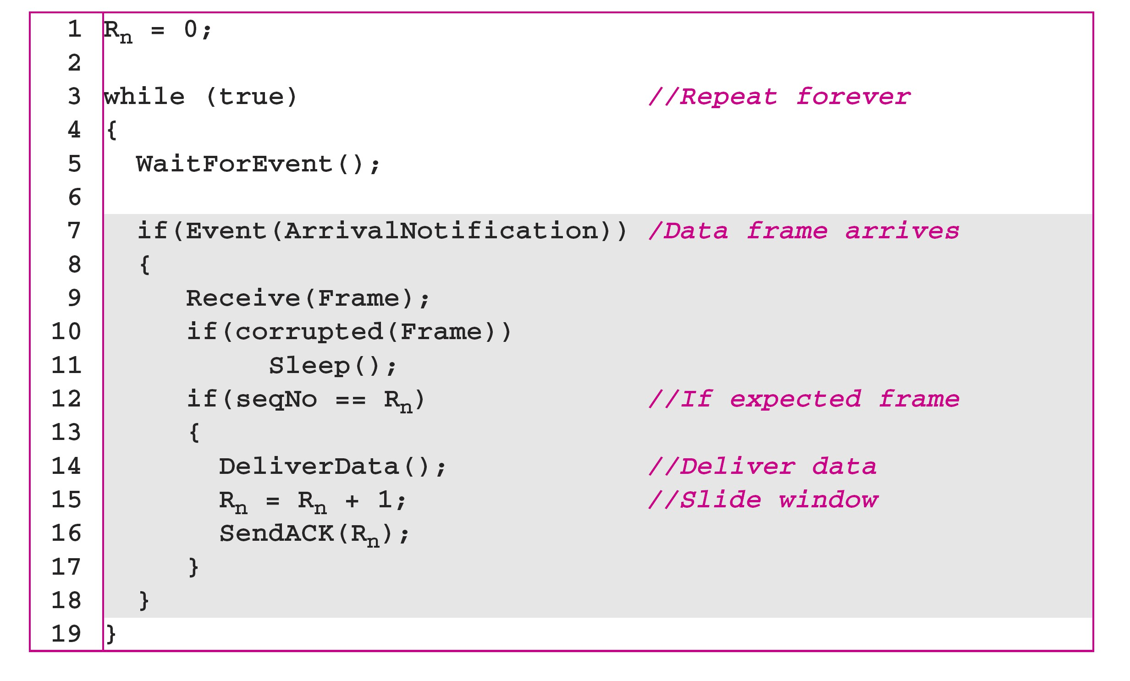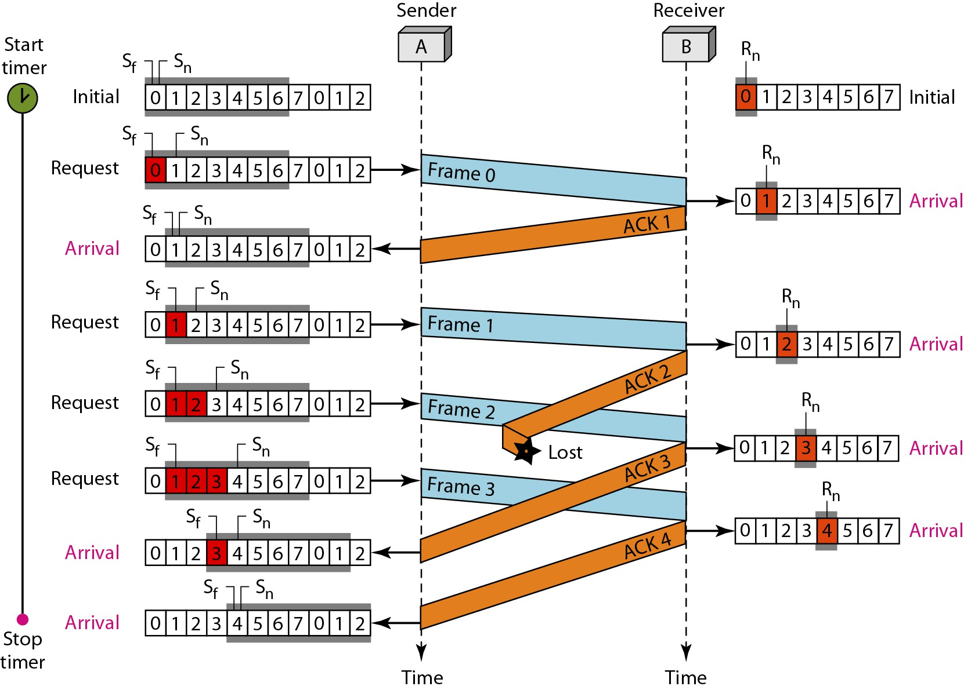

Algorithm 11.7 *Go-Back-N sender algorithm*  (continued)

11.46

*Example 11.6*

*Figure 11.16 shows an example of Go-Back-N. This is an*   
*example of a case where the forward channel is reliable,*

*but the reverse is not. No data frames are lost, but some*

*ACKs are delayed and one is lost. The example also*   
*shows how cumulative acknowledgments can help if*   
*acknowledgments are delayed or lost. After initialization,*   
*there are seven sender events. Request events are*   
*triggered by data from the network layer; arrival events*   
*are triggered by acknowledgments from the physical*

*layer. There is no time-out event here because all*

*outstanding frames are acknowledged before the timer*   
*expires. Note that although ACK 2 is lost, ACK 3 serves as*

*both ACK 2 and ACK 3.*

Algorithm 11.8 *Go-Back-N receiver algorithm*

11.47

Figure 11.16 *Flow diagram for Example 11.6*

11.48

11.49

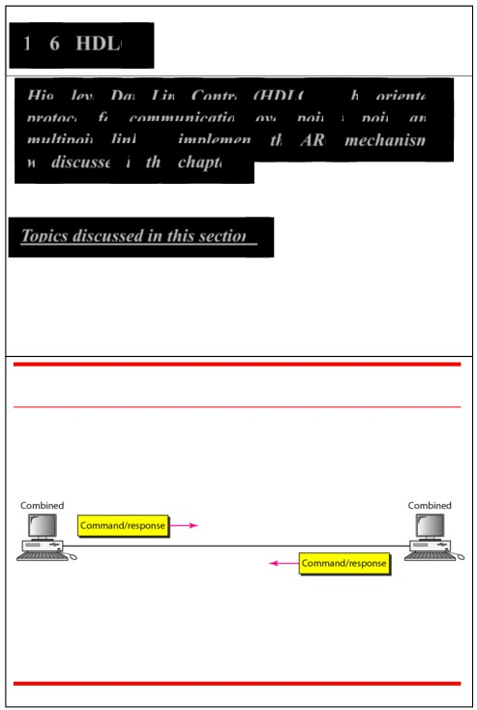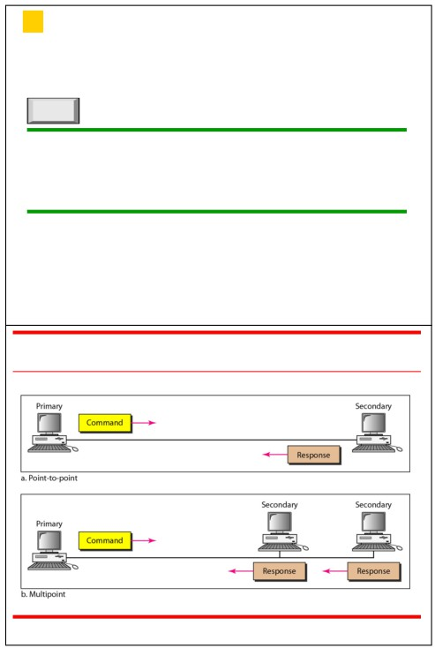

11-6 HDLC

*High-level Data Link Control (HDLC) is a bit-oriented*

*Note*

*protocol for communication over point-to-point and*

*multipoint links. It implements the ARQ mechanisms*

Stop-and-Wait ARQ is a special case of *we discussed in this chapter.*

Go-Back-N ARQ in which the size of the   
 send window is 1.

*Topics discussed in this section:*

Frames

Control Field

11.50 11.51

Figure 11.25 *Normal response mode* Figure 11.26 *Asynchronous balanced mode*

11.52

11.53

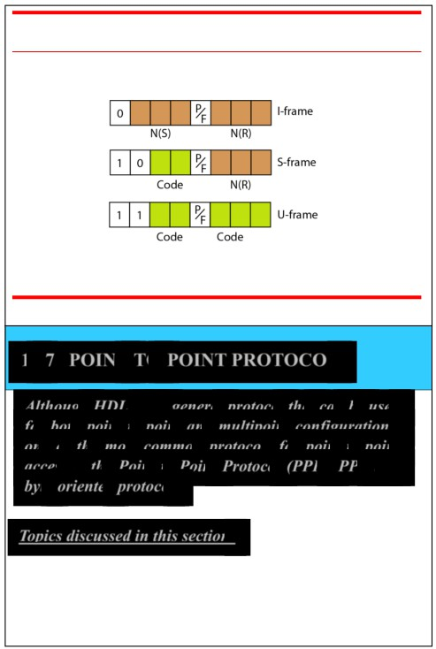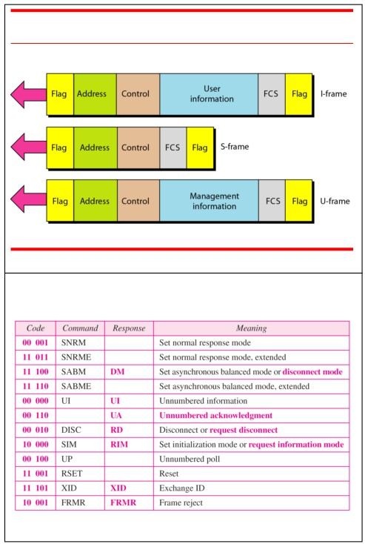

Figure 11.27 *HDLC frames*

11.54

Table 11.1 *U-frame control command and response*

11.56

Figure 11.28 *Control field format for the different frame types*

11.55

11-7 POINT-TO-POINT PROTOCOL

*Although HDLC is a general protocol that can be used*

*for both point-to-point and multipoint configurations, one of the most common protocols for point-to-point access is the Point-to-Point Protocol (PPP). PPP is a byte-oriented protocol.*

*Topics discussed in this section:*

Transition Phases Multiplexing

Multilink PPP

11.57

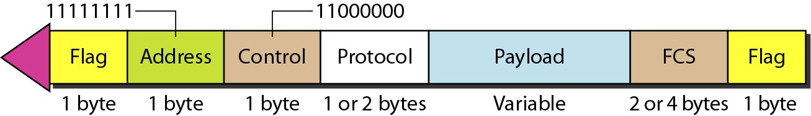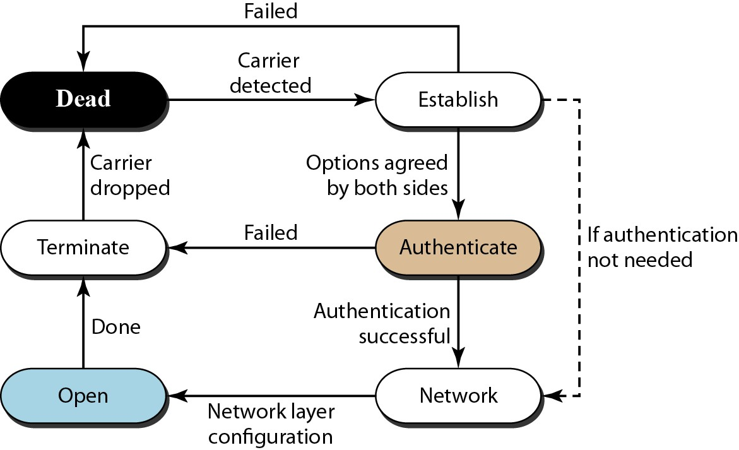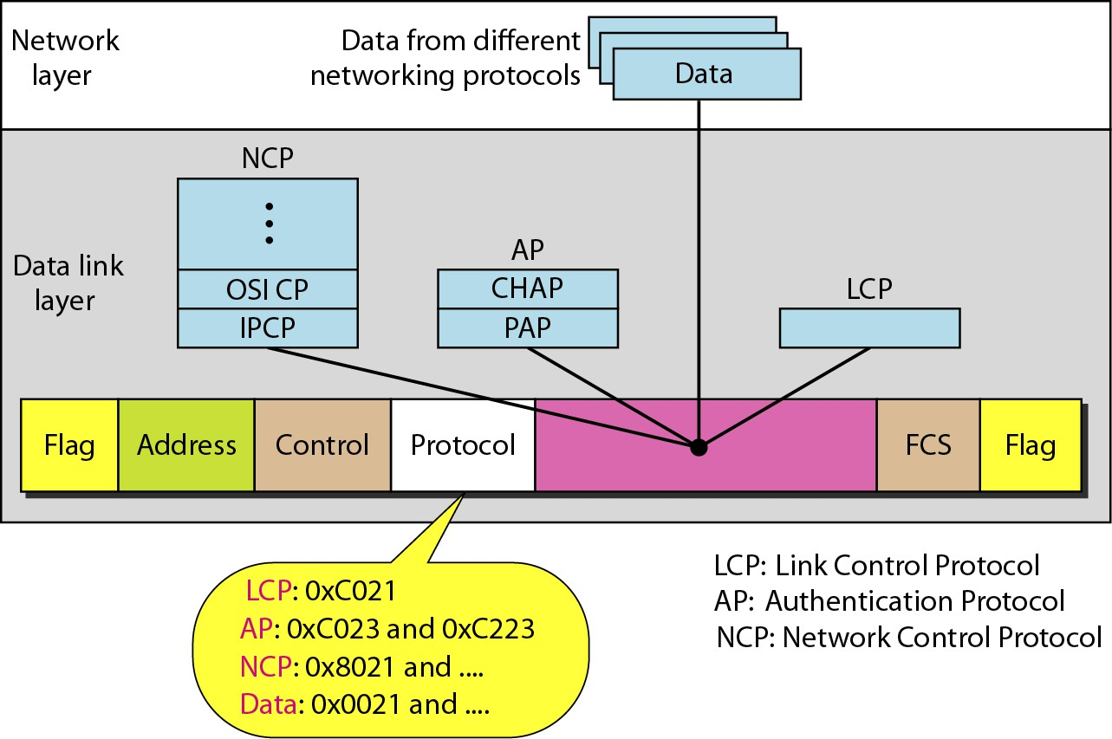

Figure 11.32 *PPP frame format*

*Note*

PPP is a byte-oriented protocol using byte stuffing with the escape byte   
 01111101.

11.58 11.59

Figure 11.33 *Transition phases* Figure 11.34 *Multiplexing in PPP*

11.60

11.61

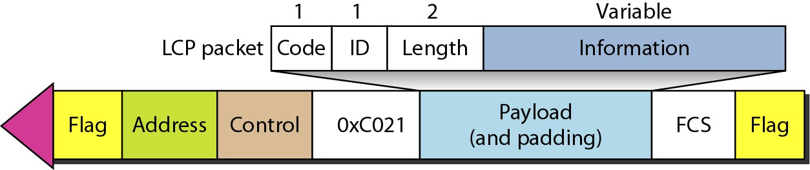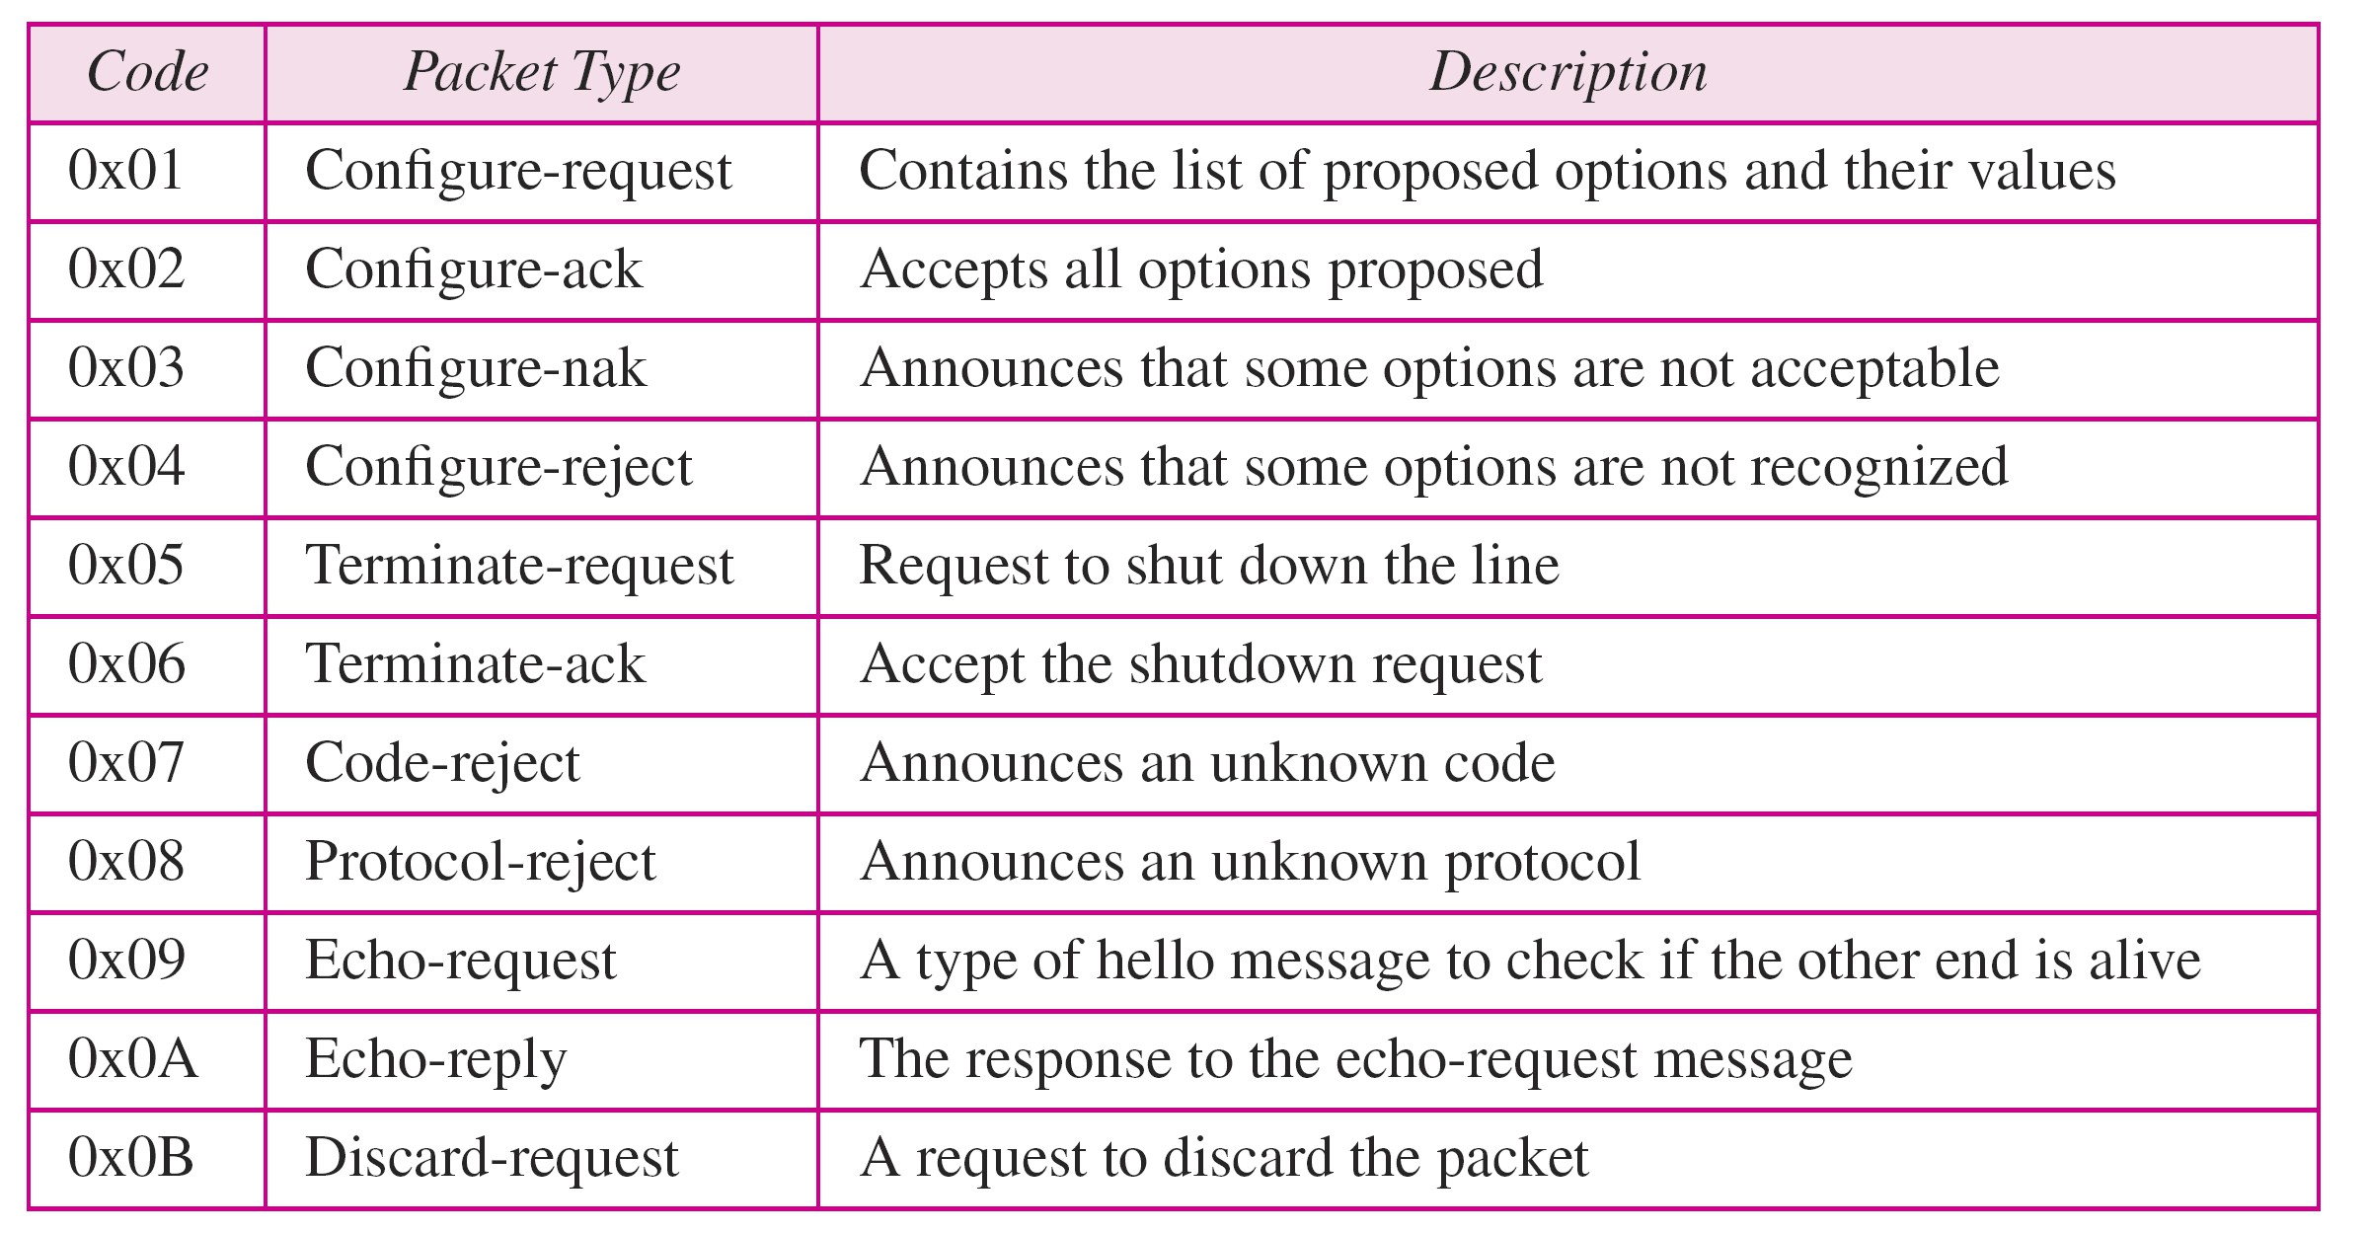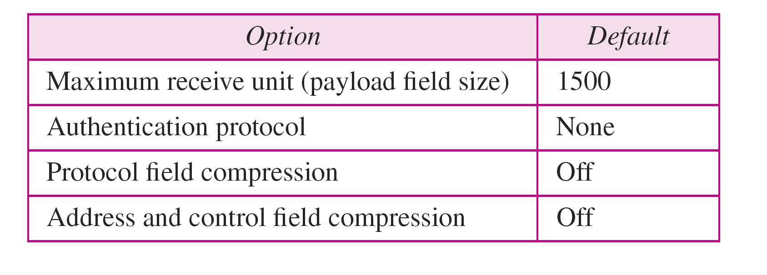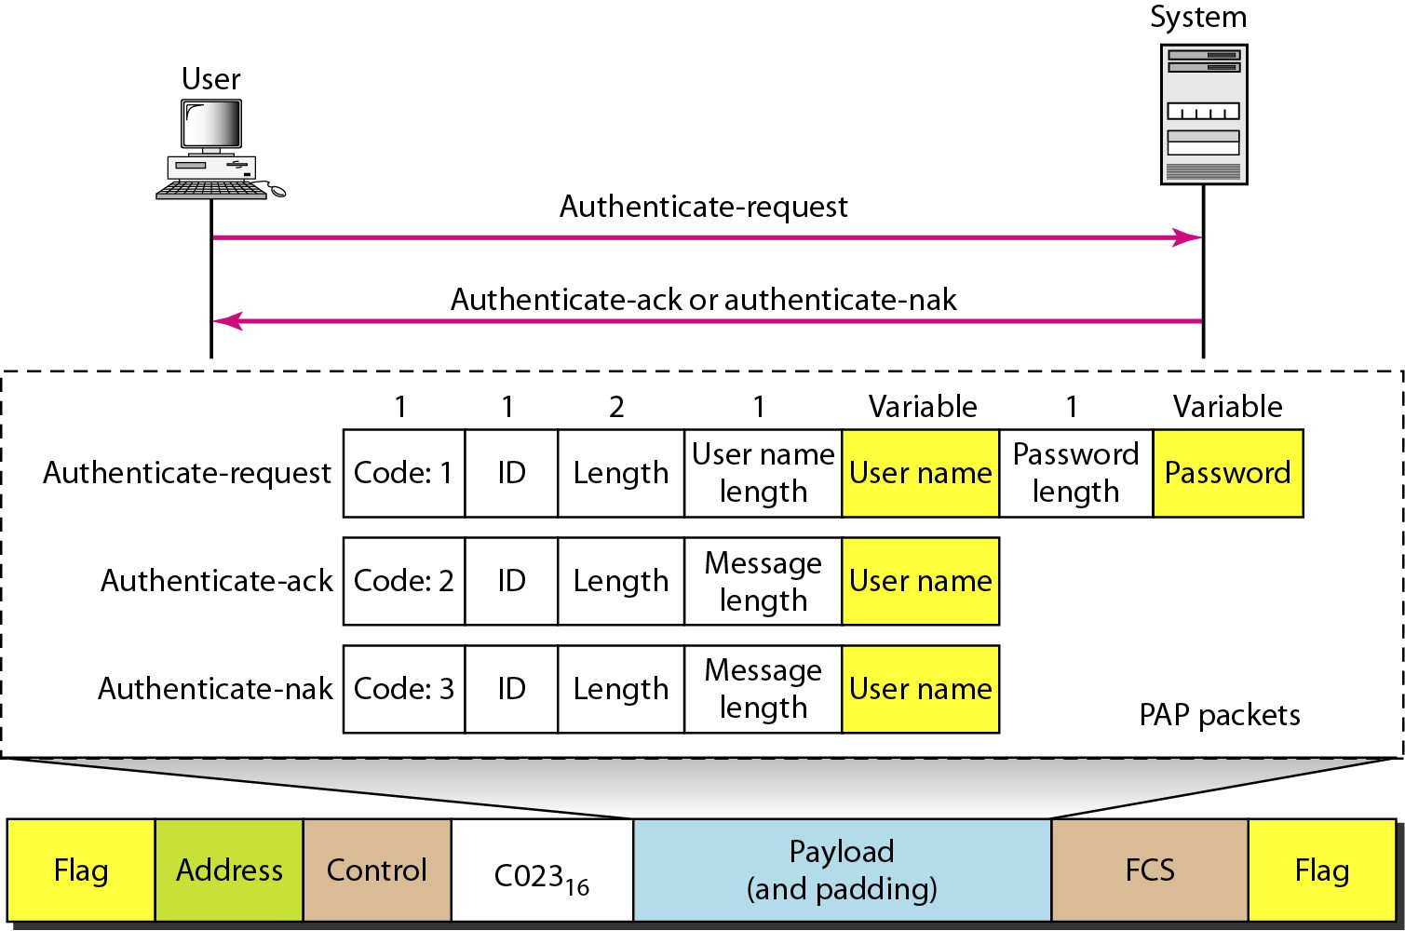

Figure 11.35 *LCP packet encapsulated in a frame*

Table 11.2 *LCP packets*

11.62 11.63

Figure 11.36 *PAP packets encapsulated in a PPP frame*

Table 11.3 *Common options*

11.64

11.65

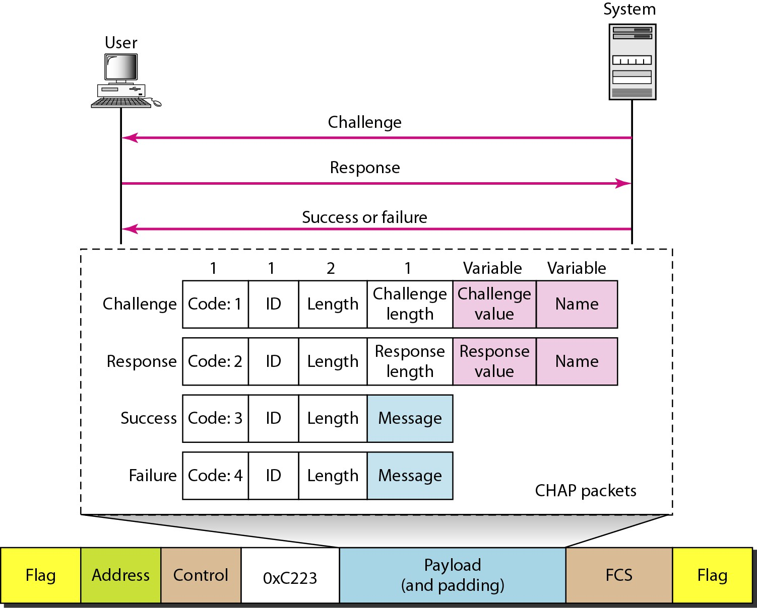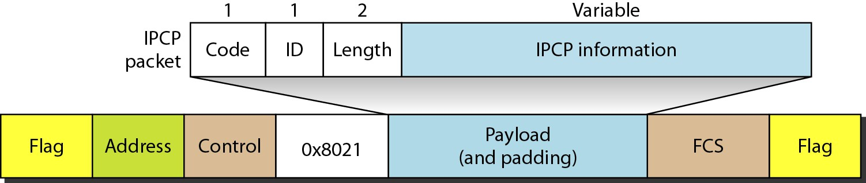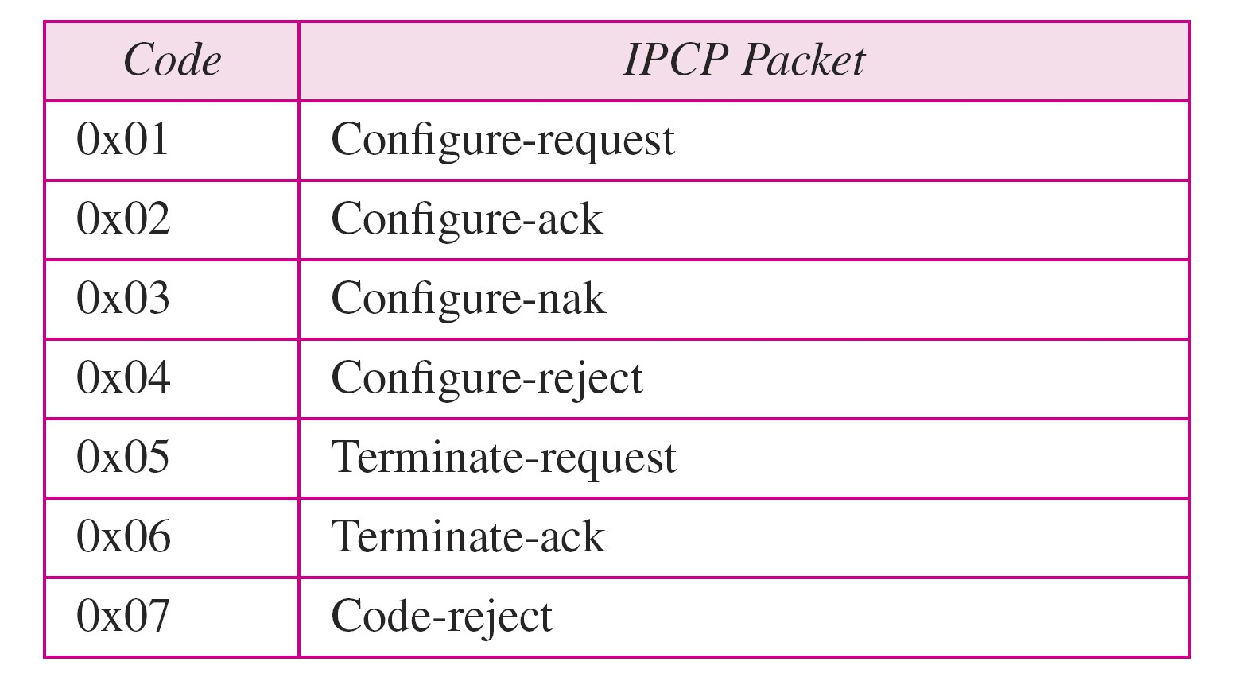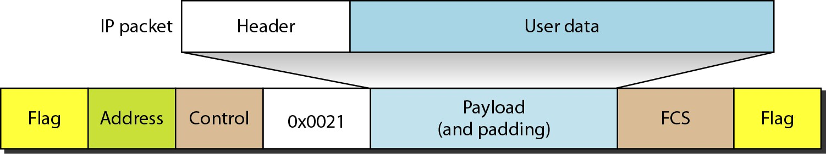

Figure 11.37 *CHAP packets encapsulated in a PPP frame* Figure 11.38 *IPCP packet encapsulated in PPP frame*

11.66 11.67

Figure 11.39 *IP datagram encapsulated in a PPP frame*

Table 11.4 *Code value for IPCP packets*

11.68

11.69

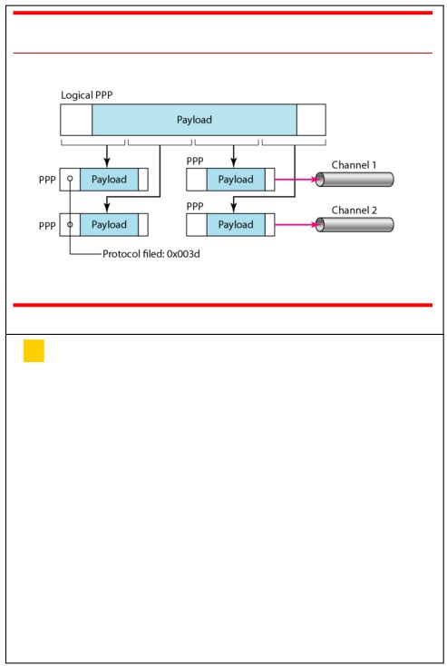

Figure 11.40 *Multilink PPP*

10-5 CHECKSUM

*The last error detection method we discuss here is*

*called the checksum. The checksum is used in the*   
*Internet by several protocols although not at the*

*data link layer. However, we briefly discuss it here to*

*complete our discussion on error checking*

*Topics discussed in this section:*

One’s Complement

Internet Checksum

1

11.70

*Example 10.18*

*Suppose our data is a list of five 4-bit numbers that we*

*want to send to a destination. In addition to sending*   
*these numbers, we send the sum of the numbers. For*

*example, if the set of numbers is (7, 11, 12, 0, 6), we*   
*send (7, 11, 12, 0, 6, 36), where 36 is the sum of the*   
*original numbers. The receiver adds the five numbers*   
*and compares the result with the sum. If the two are the*

*same, the receiver assumes no error, accepts the five*

*numbers, and discards the sum. Otherwise, there is an error somewhere and the data are not accepted.*

2

10.

*Example 10.19*

*We can make the job of the receiver easier if we send*

*the negative (complement) of the sum, called the*   
*checksum. In this case, we send (7, 11, 12, 0, 6,* −*36).*   
*The receiver can add all the numbers received*

*(including the checksum). If the result is 0, it assumes no error; otherwise, there is an error.*

3

10. 10.

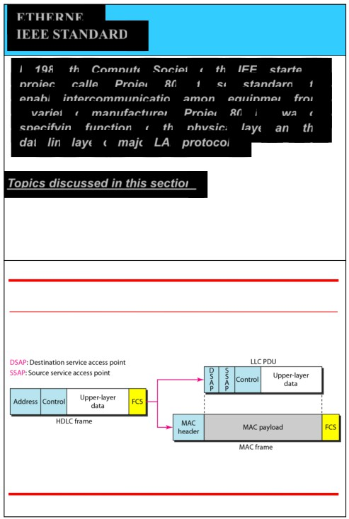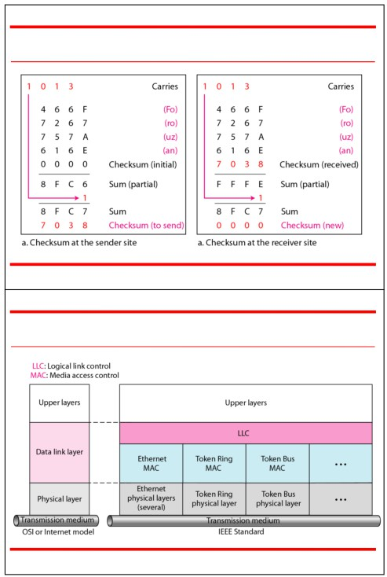

ETHERNET

10.

Figure 10.25 *Example 10.23*

IEEE STANDARDS

*In 1985, the Computer Society of the IEEE started a*

*project, called Project 802, to set standards to*   
*enable intercommunication among equipment from*   
*a variety of manufacturers. Project 802 is a way of*

*specifying functions of the physical layer and the*

*data link layer of major LAN protocols.*

*Topics discussed in this section:*

Data Link Layer

Physical Layer

4 5

Figure 13.1 *IEEE standard for LANs* Figure 13.2 *HDLC frame compared with LLC and MAC frames*

6 7

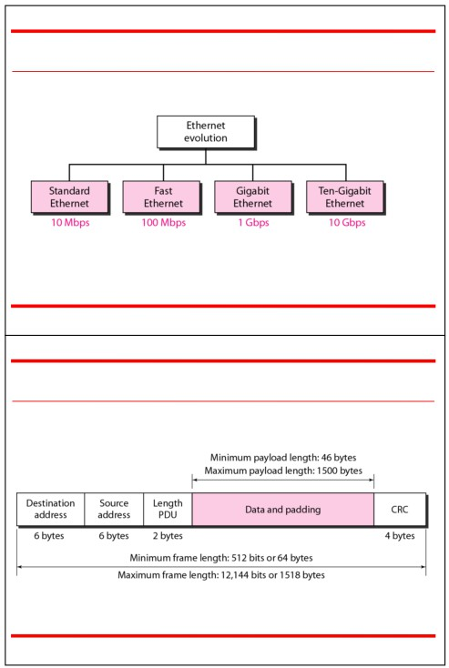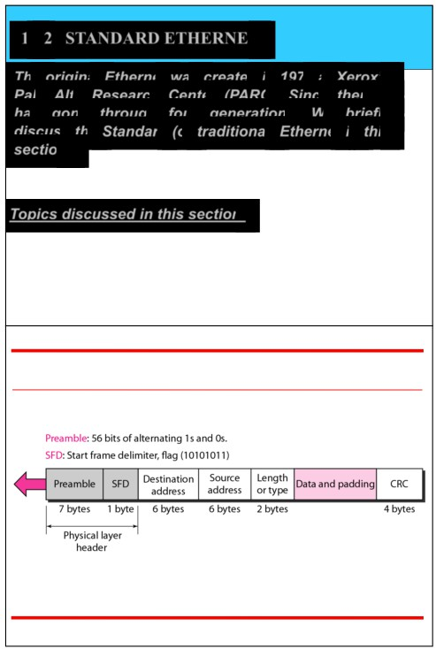

13-2 STANDARD ETHERNET

Figure 13.3 *Ethernet evolution through four generations*

*The original Ethernet was created in 1976 at* Xerox’s   
*Palo Alto Research Center (PARC). Since then, it*   
*has gone through four generations. We briefly*   
*discuss the Standard (or traditional) Ethernet in this*   
*section.*

*Topics discussed in this section:*

MAC Sublayer

Physical Layer

8 9

Figure 13.4 *802.3 MAC frame* Figure 13.5 *Minimum and maximum lengths*

10 11

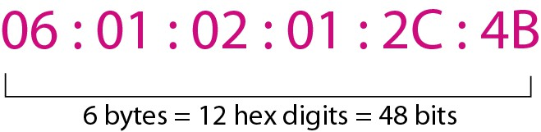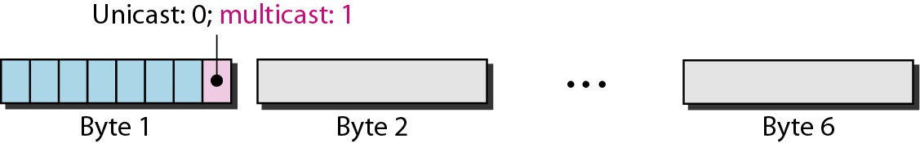

Figure 13.6 *Example of an Ethernet address in hexadecimal notation*

*Note*

Frame length:

Minimum: 64 bytes (512 bits)

Maximum: 1518 bytes (12,144 bits)

12 13

Figure 13.7 *Unicast and multicast addresses*

*Note*

The least significant bit of the first byte

defines the type of address.

If the bit is 0, the address is unicast;   
 otherwise, it is multicast.

14 15

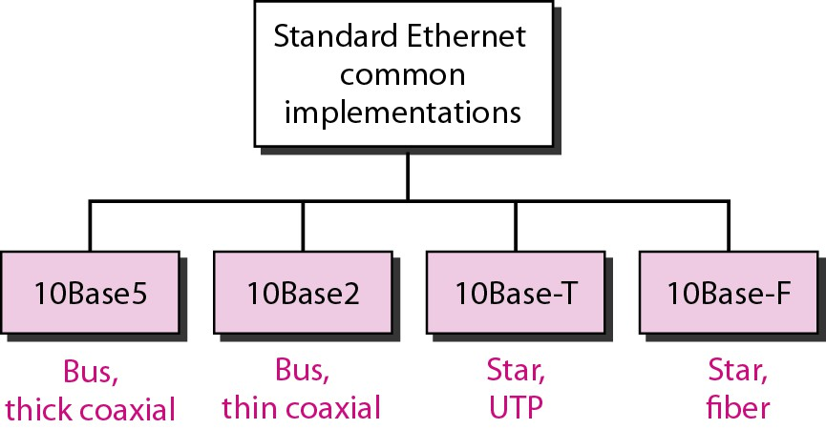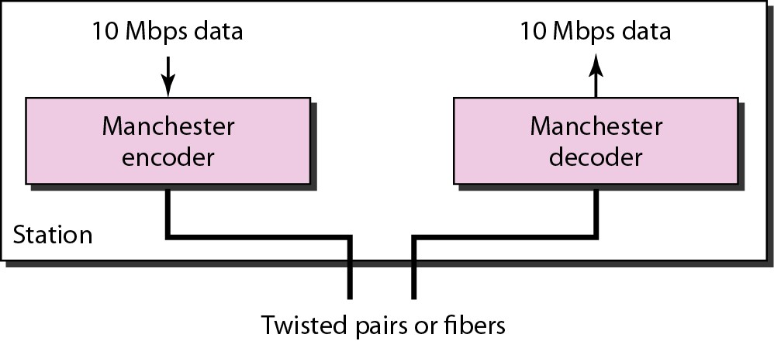

*Example 13.1*

*Define the type of the following destination addresses:*

*Note*

*a.*  *4A:30:10:21:10:1A*

*c. FF:FF:FF:FF:FF:FF*

*Solution*

*b.*  *47:20:1B:2E:08:EE*

The broadcast destination address is a

special case of the multicast address in

which all bits are 1s.

16

*To find the type of the address, we need to look at the second hexadecimal digit from the left. If it is even, the address is*

unicast. If it is odd, the address is multicast. If all digits are F’s,

*the address is broadcast. Therefore, we have the following:*

*a. This is a unicast address because A in binary is 1010.*

*b. This is a multicast address because 7 in binary is 0111.*

*c.* This is a broadcast address because all digits are F’s.

17

Figure 13.8 *Categories of Standard Ethernet* Figure 13.9 *Encoding in a Standard Ethernet implementation*

18 19

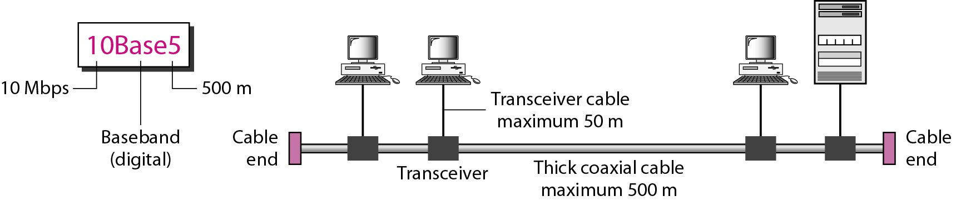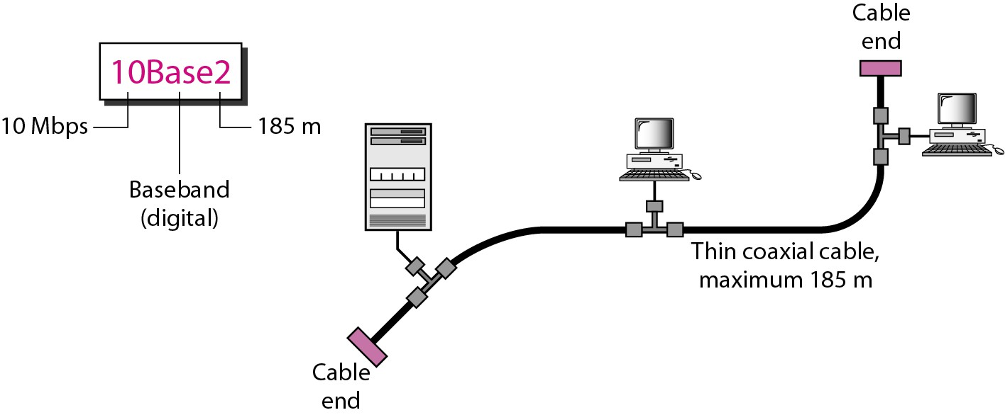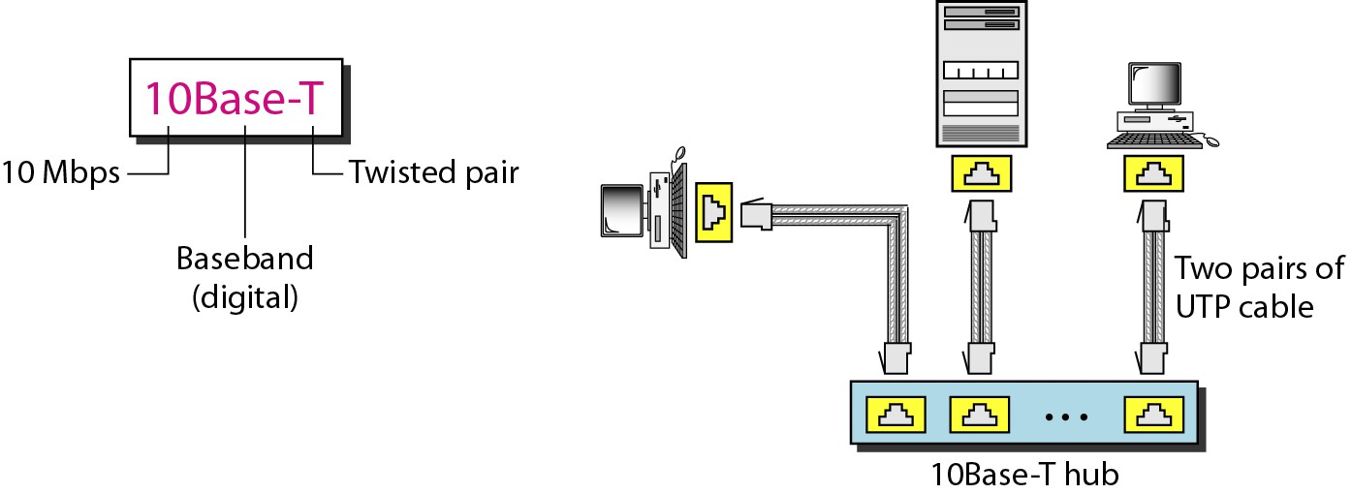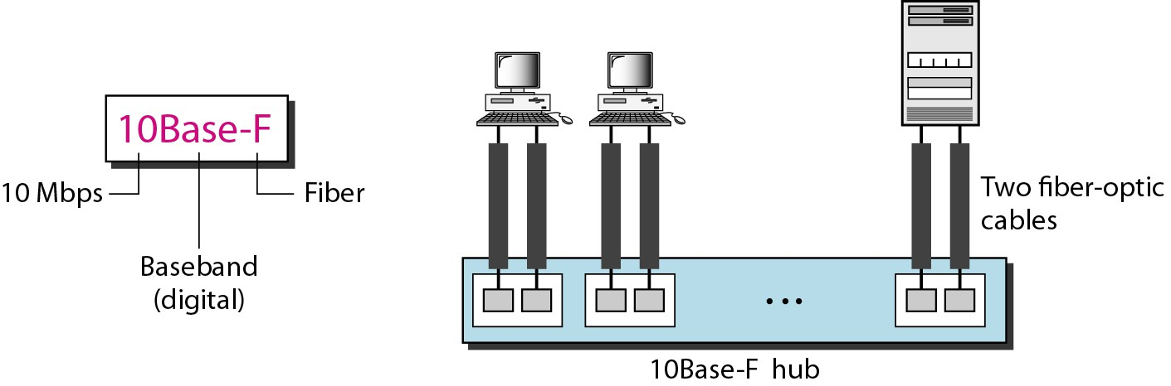

Figure 13.10 *10Base5 implementation* Figure 13.11 *10Base2 implementation*

20 21

Figure 13.12 *10Base-T implementation* Figure 13.13 *10Base-F implementation*

22 23

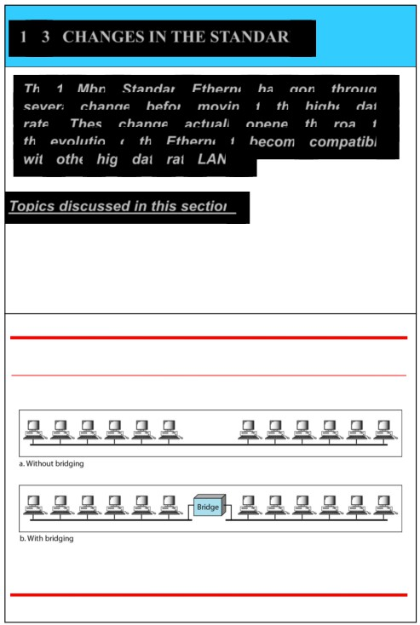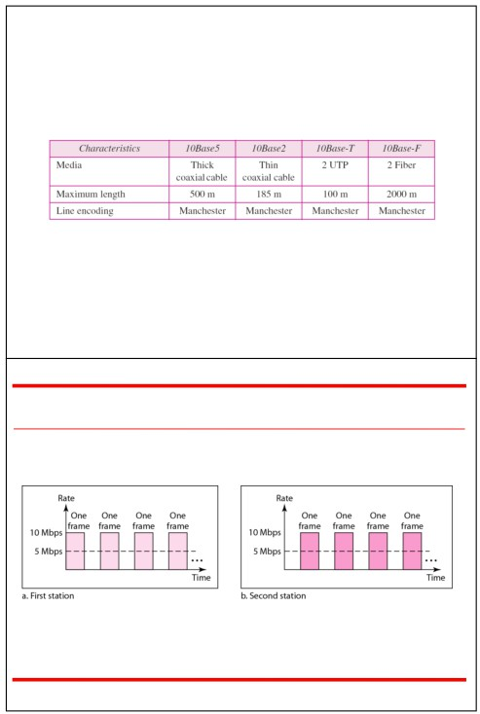

13-3 CHANGES IN THE STANDARD

*The 10-Mbps Standard Ethernet has gone through*

Table 13.1 *Summary of Standard Ethernet implementations*

*several changes before moving to the higher data*

*rates. These changes actually opened the road to the evolution of the Ethernet to become compatible with other high-data-rate LANs.*

*Topics discussed in this section:*

Bridged Ethernet

Switched Ethernet

Full-Duplex Ethernet

Figure 13.14 *Sharing bandwidth*

24

Figure 13.15 *A network with and without a bridge*

25

26 27

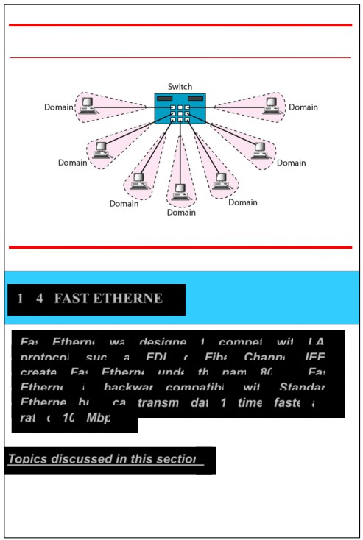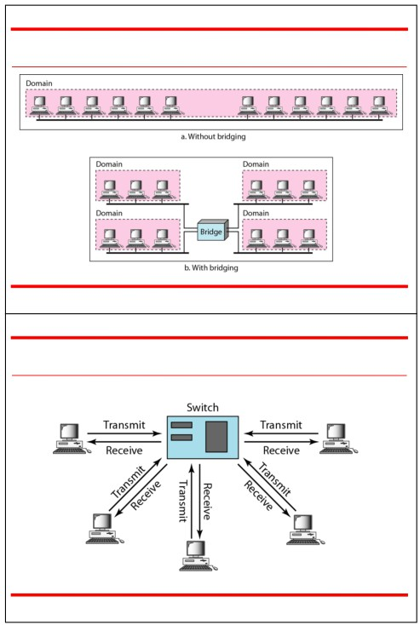

Figure 13.16 *Collision domains in an unbridged network and a bridged network* Figure 13.17 *Switched Ethernet*

28 29

13-4 FAST ETHERNET

Figure 13.18 *Full-duplex switched Ethernet*

*Fast Ethernet was designed to compete with LAN*

*protocols such as FDDI or Fiber Channel. IEEE*   
*created Fast Ethernet under the name 802.3u. Fast*

*Ethernet is backward-compatible with Standard*

*Ethernet, but it can transmit data 10 times faster at a rate of 100 Mbps.*

*Topics discussed in this section:*

MAC Sublayer

Physical Layer

30 31

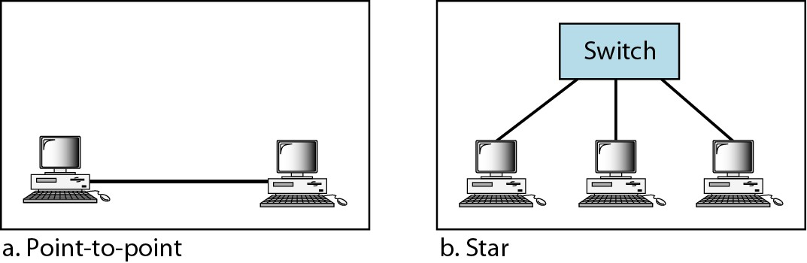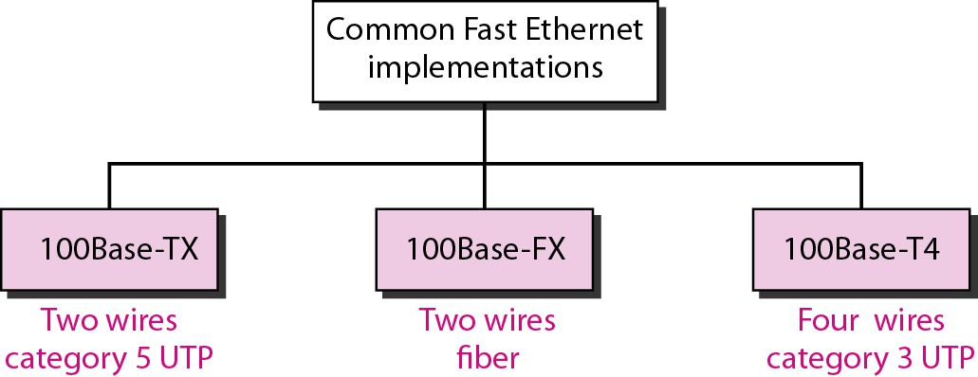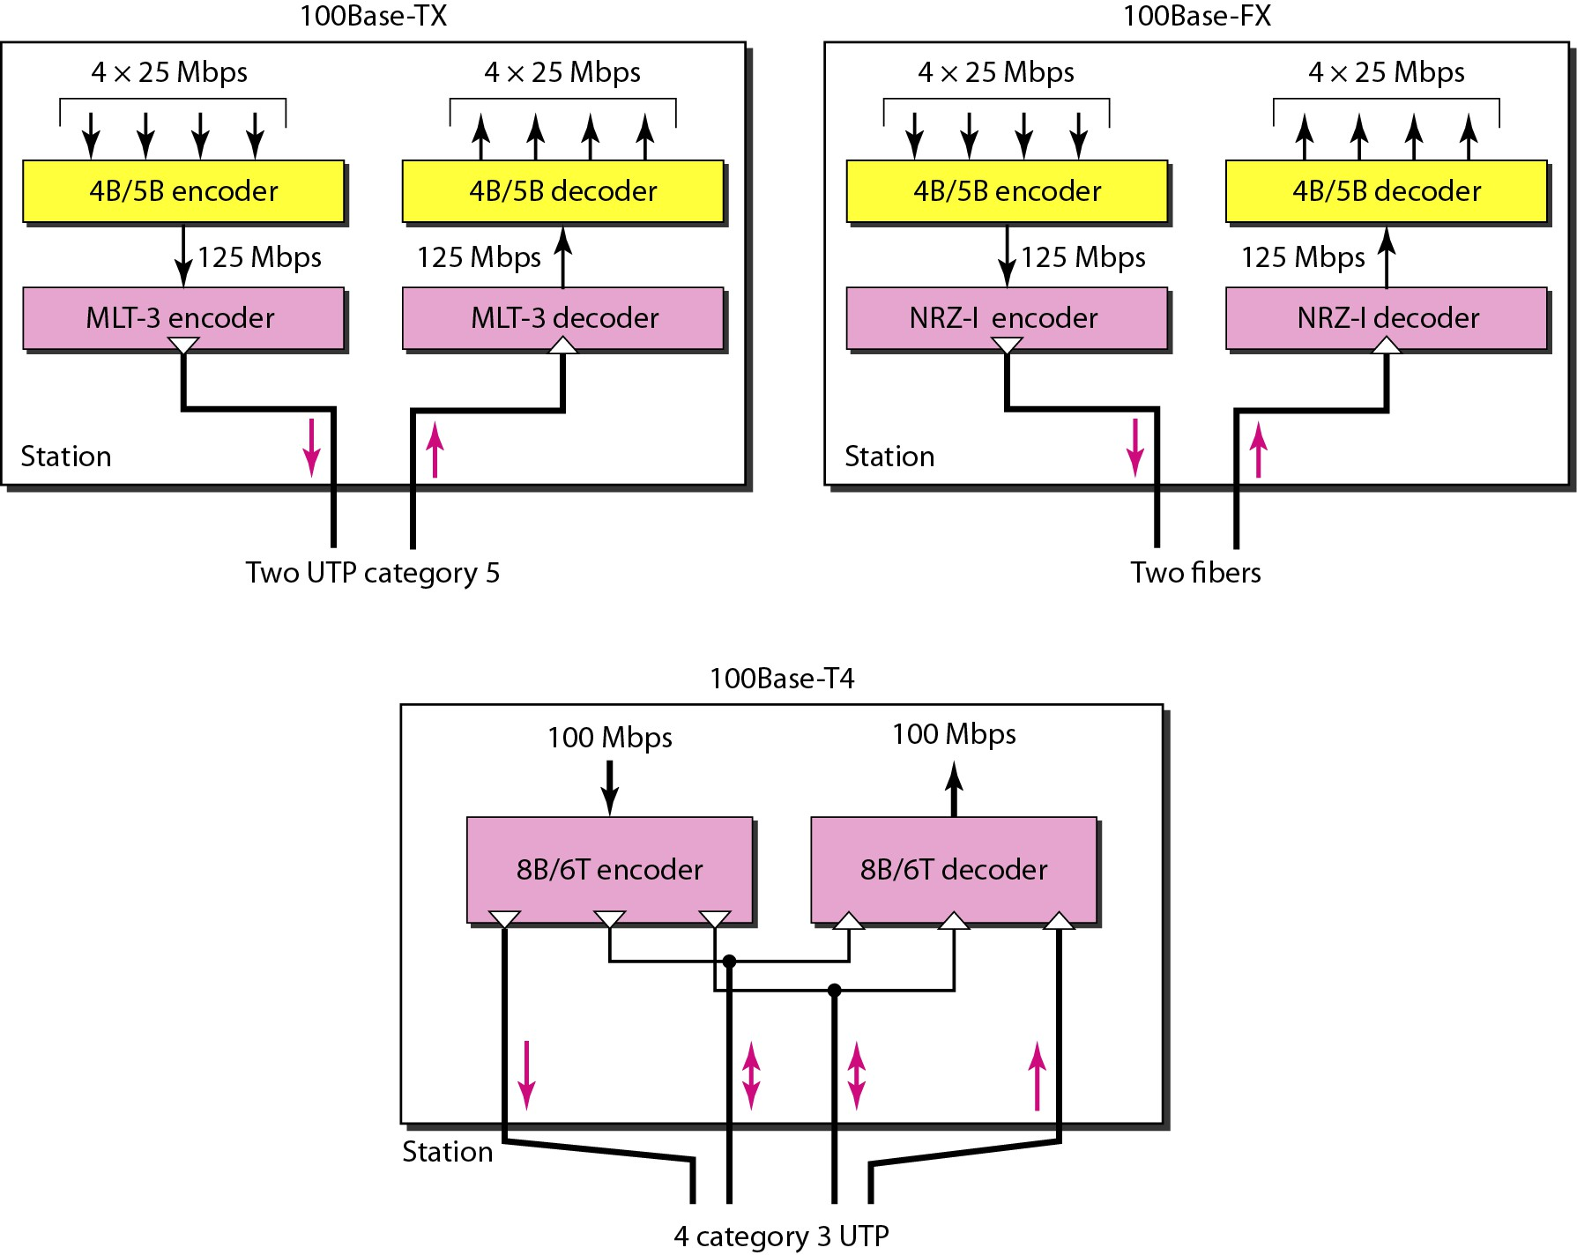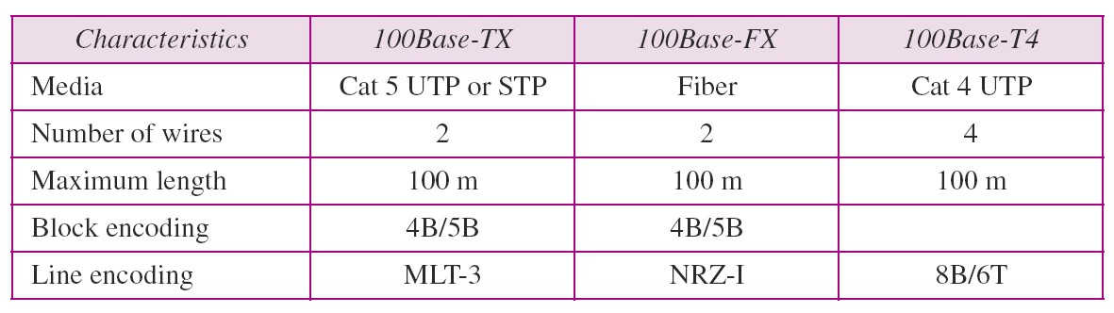

Figure 13.19 *Fast Ethernet topology* Figure 13.20 *Fast Ethernet implementations*

32 33

Figure 13.21 *Encoding for Fast Ethernet implementation*

Table 13.2 *Summary of Fast Ethernet implementations*

34 35

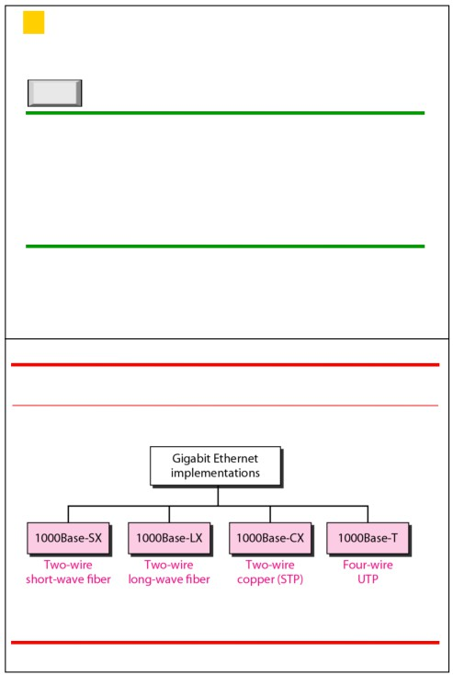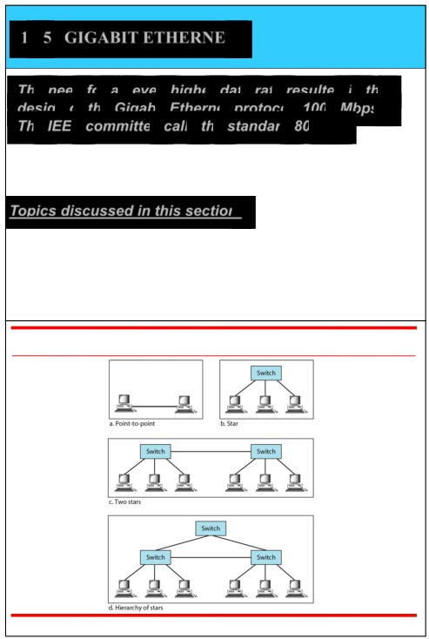

13-5 GIGABIT ETHERNET

*The need for an even higher data rate resulted in the*

*design of the Gigabit Ethernet protocol (1000 Mbps).*

*The IEEE committee calls the standard 802.3z.*

*Topics discussed in this section:*   
 MAC Sublayer

Physical Layer   
Ten-Gigabit Ethernet

*Note*

In the full-duplex mode of Gigabit Ethernet,

there is no collision;

the maximum length of the cable is

determined by the signal attenuation

in the cable.

36 37

Figure 13.22 *Topologies of Gigabit Ethernet*

Figure 13.23 *Gigabit Ethernet implementations*

38 39

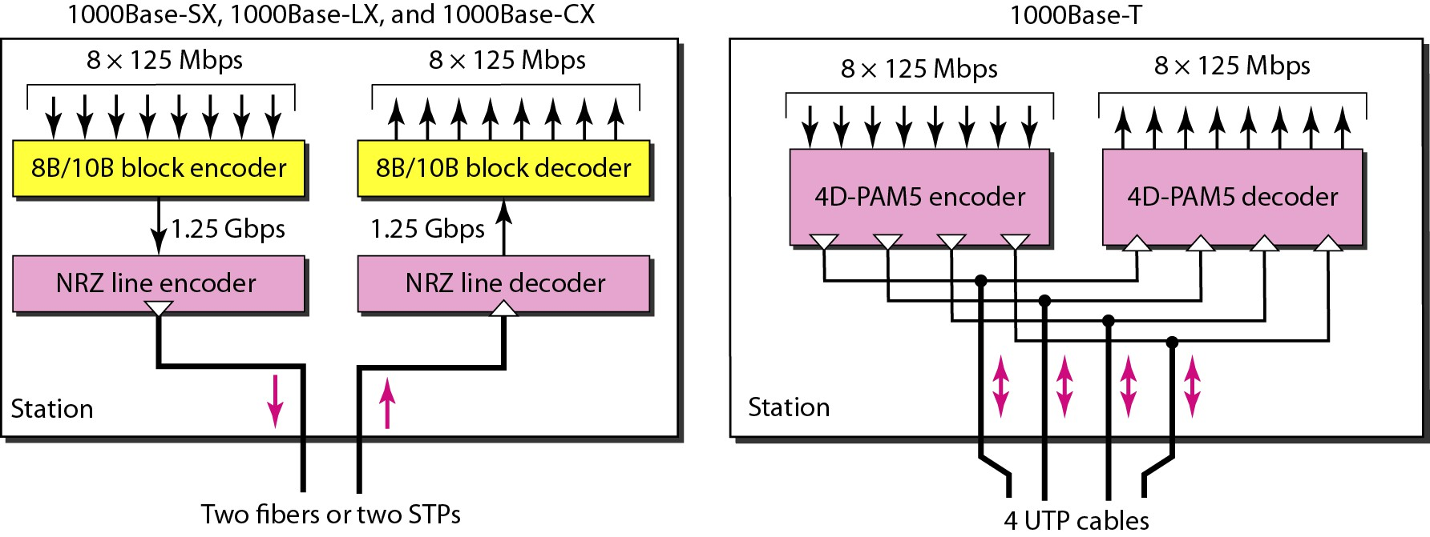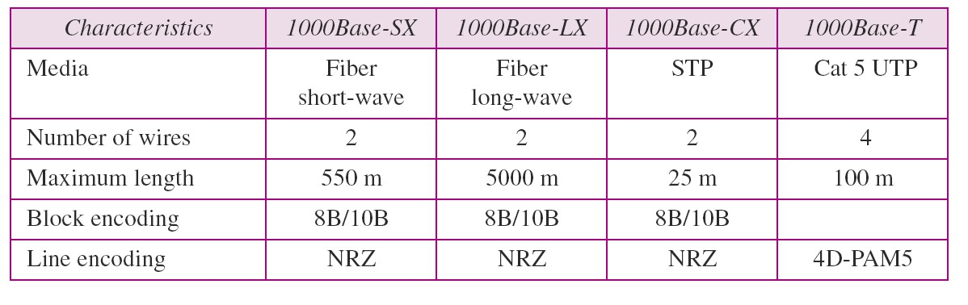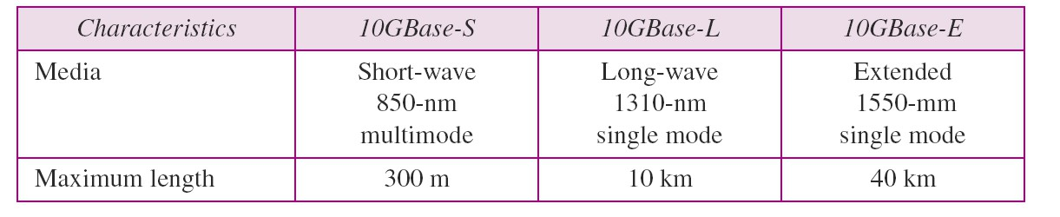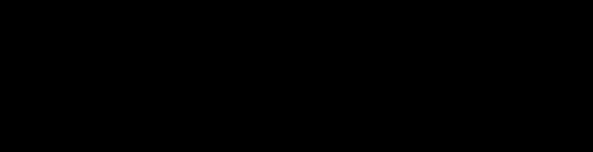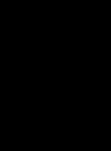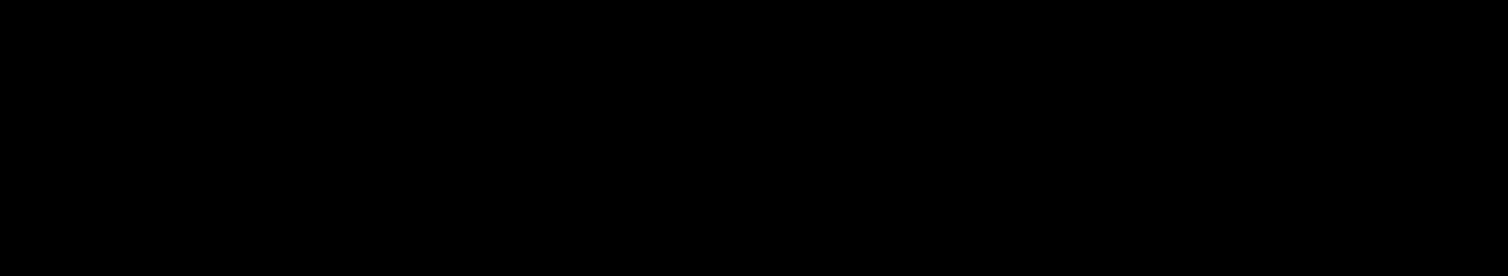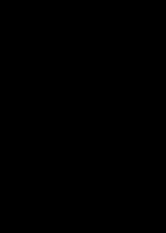

Figure 13.24 *Encoding in Gigabit Ethernet implementations*

Table 13.3 *Summary of Gigabit Ethernet implementations*

Table 13.4 *Summary of Ten-Gigabit Ethernet implementations*

40 41

Token Ring/IEEE 802.5

Click to add Text

42

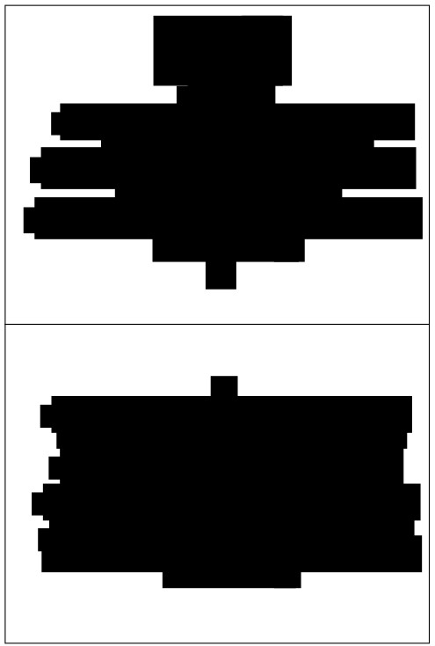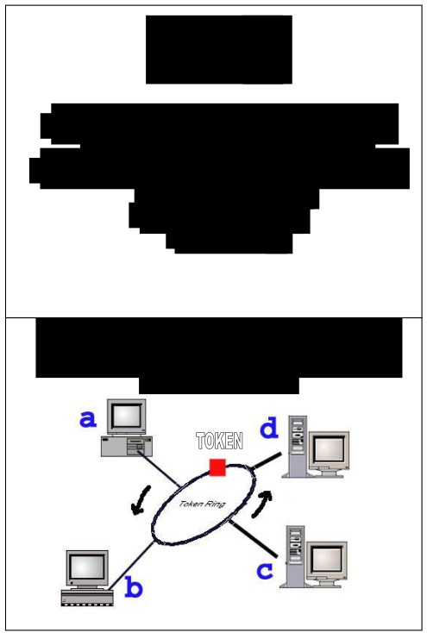

History

Token

■ Token

■ The Token Ring network was originally   
 developed by IBM in the 1970s.

■ It is still IBM's primary local-area network   
 (LAN) technology.

■ Resource sharing

■ Round Robin

Access Method :Token

Passing

■ simple placeholder frame that is passed from   
 station to station around the ring.

■ A station may send data only when it has   
 possession of the token

■ Token ring allows each station to send one   
 frame per turn

■ This token is passed from NIC (yellow box) to   
 NIC in sequence until it encounters a station

with data to send.

■ That station (a,b,c,d) waits for the token to   
 enter its network board

■ If the token is free, the station may then send a   
 data frame

■ It keeps the token and sets a bit inside its NIC   
 as a reminder that it has done so, then sends its

one data frame

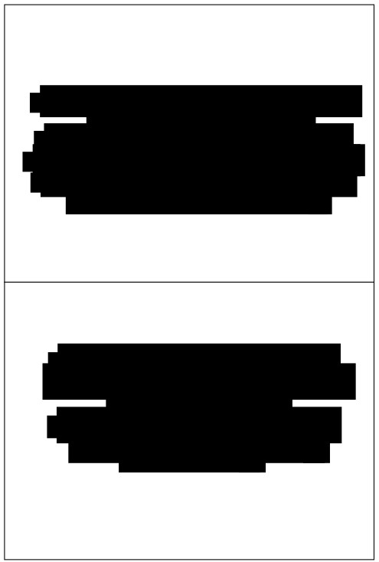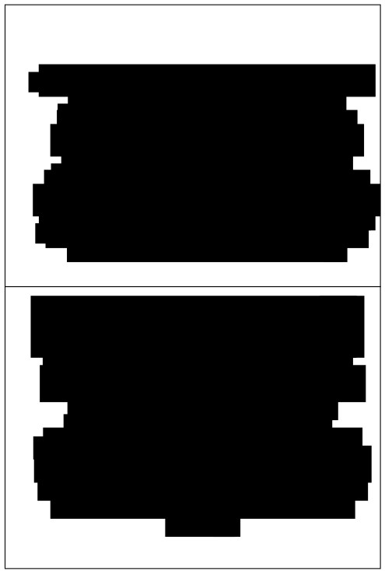

■ This data frame proceeds around the ring, being

regenerated by each station.

■ Each intermediate station examines the   
 destination address, finds that the frame is   
address to another station and relays it to its

neighbor

■ The intended recipient recognizes its own   
address, copies the message, checks for errors

and changes four bits in the last byte of the frame

to indicate address recognized and frame copied   
■ The full packet then continues around the ring

until it returns to the station that sent it

Priority and reservation

■ The busy token can be reserved by a   
station waiting to transmit, regardless of

that station’s location on the ring   
■ Each station has a priority code

■ As a frame pass by, a station waiting to

transmit may reserve the next open token   
 by entering its priority code in the access

control (AC) field of the token or data   
 frame.

■ The sender receives the frame and recognized   
 itself in the source address field

■ It then examines the address-recognized bits   
■ If they are set, it knows the frame was received.

■ The sender then discards the used data frame   
 and release the token back to the ring

■ A station with a higher priority may   
remove a lower priority reservation and

replace it with its own

■ Among station of equal priority, the   
 process is first come, first serve.

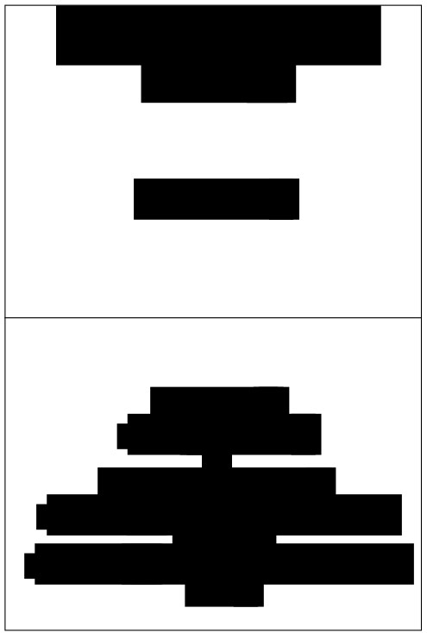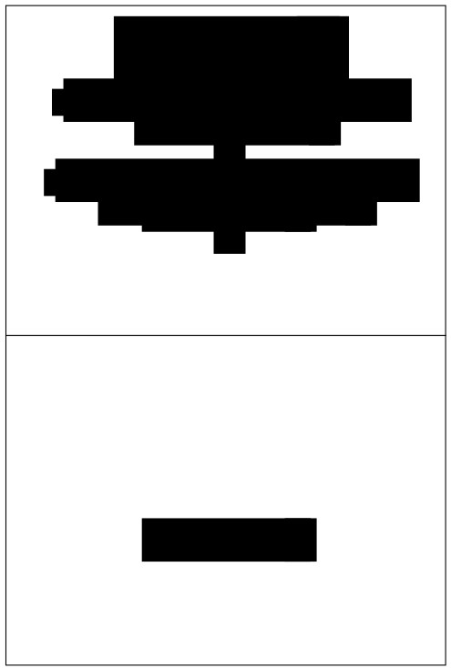

Time Limits

■ Token ring - imposes time limit (any   
 station use the ring)

■ Each station expects to receive frames   
 within regular time intervals.

1. One station on the ring designated as a monitor

2. It set timer every time the token passing

3. If token does not reappear in the allotted time - assumed

lost and monitor generates a new tokens and introduces it

to ring.

4. The monitor guards the recirculating data frames by

How to setting a bit in the AC field of each frame.

solve

5. As a frame passes, the monitor checks the status field. If   
it has been set, the packet has already been around the ring

and should be discarded.

6.The monitor then destroys the frame and puts a token onto the ring.

7. If the monitor fails, a second, designed as a back-up, takes over.

Problems: Monitor

Station

■ Station neglect to retransmit a token   
 ■ Token destroyed by noise

■ No token on the ring

■ No station may send the data

Click to add Text

■ Sending station may neglect to remove   
 its used data frame from the ring   
■ May not release the token once its turn

has ended

Addressing

■ uses 6-byte address

Electrical specification

■ Signaling - uses differential Manchester   
 encoding

■ Data Rate - support data rates of up to 18   
 Mbps.

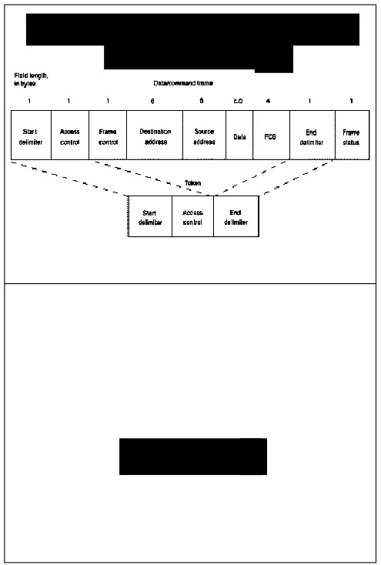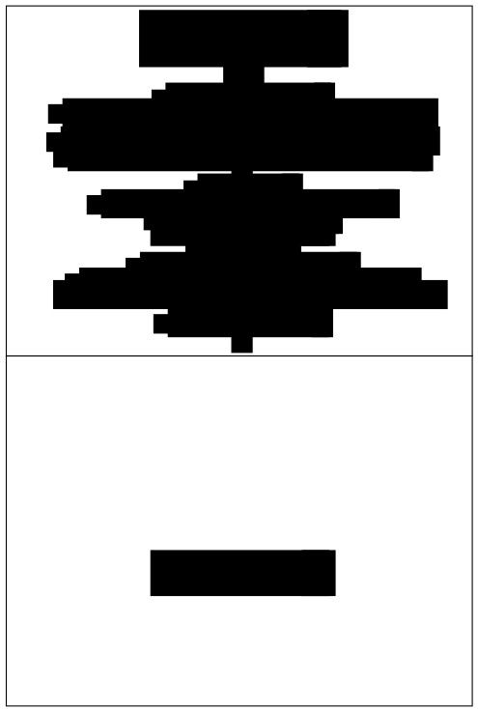

Frame formats

IEEE 802.5 and Token Ring Specify Tokens and

Data/Command Frames

■ Data/Command Frame

-

-

the only one out of three that can carry PDU and address to a   
 specific destination.

Can carry either the user data or the management commands.

- Has 9 fields of the frame (SD,AC,FC,DA,SA,Data,CRC,ED,FS)

■ Token Frame

- function as a placeholder and reservation frame.

- Has only 3 fields (SD,AC,ED)

■ Abort Frame

- doesn’t carry any information at all

- It can be generated either by the sender to stop its own

transmission or by the monitor to purge an old transmission from   
 the line.

- Has only 2 fields (SD,ED)

Fields in the Frame Format

Data

Start delimiter

•Alerts each station of the arrival of a token.

•Includes signals that distinguish the byte from the rest of the frame by violating the encoding scheme used elsewhere in the frame.

Access-control byte

•Priority field - the most significant 3 bits

•Reservation field - the least significant 3 bits

•a token bit - used to differentiate a token from a data/command frame

•a monitor bit - used by the active monitor to determine whether a frame is circling the ring endlessly. Click to add Text

Frame-control bytes

•Indicates whether the frame contains data or control information.

•In control frames, this byte specifies the type of control information.

Destination and source addresses

•Consists of two 6-byte address fields

•Identify the destination and source station addresses.

•Indicates the length of field - limited by the ring token holding time

•Defines the maximum time a station can hold the token.

Frame-check sequence (FCS)

•Filed by the source station with a calculated value dependent on the frame contents.

•The destination station recalculates the value

•If the frame was damaged in transit, the frame is discarded.

End Delimiter

•Signals the end of the token or data/command frame.

•Contains bits to indicate a damaged frame

•Identify the frame that is the last in a logical sequence.

Frame Status

•Is a 1-byte field terminating a command/data frame.

•The Frame Status field includes the address-recognized indicator and frame-  
copied indicator.

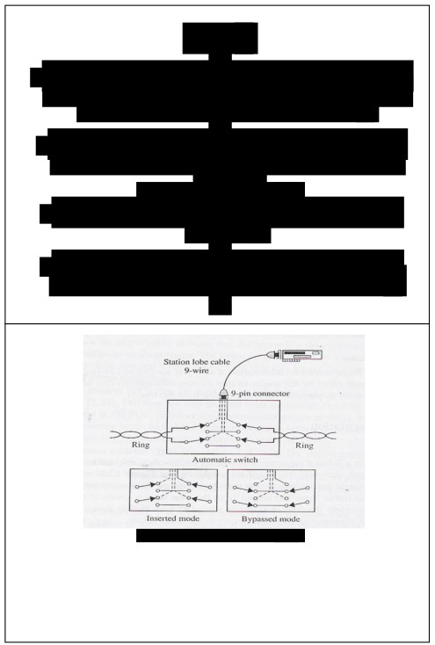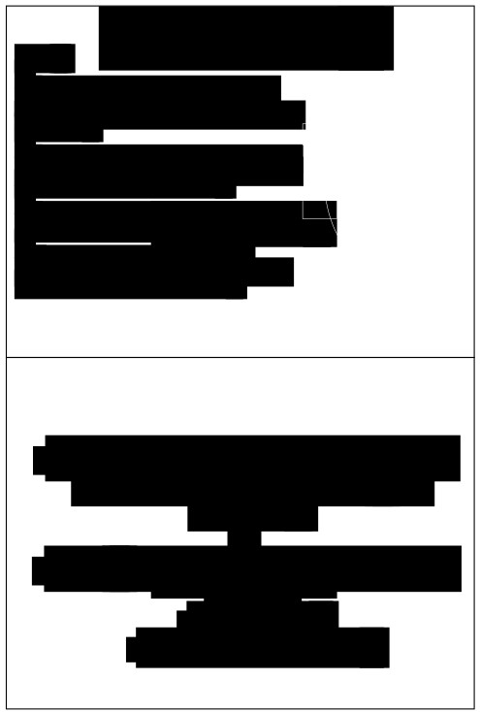

Implementation

RING

■ The ring in the token ring is consists of a Node

series of 150-ohm, shielded twisted-pair   
sections linking each station to its intermediate neighbours.

Node Node

■ Each section connects an output port on one

station to an input port on the next, creating a Ring

ring with unidirectional traffic flow.

Node Node

SWITCH

■ Configuring the network as a ring introduces a potential   
 problem: One disabled or disconnected node could stop

the flow of traffic around the entire network.

■ To solve this problem, each station is connected to an   
 automatic switch. This switch can bypass an in active

station.

■ The output from the final station connects to

the input of the first to complete the ring.

■ A frame is passed to each station in   
sequence, where it is examined, regenerated

and then sent on to the next station.

Each station regenerates the frame

■ While a station is disabled, the switch closes the ring   
 without it.

Node

■ When the station comes on, a signal sent by the NIC   
 moves the switch and brings the station into the ring.

■ Each station’s NIC has a pair of input and   
 output ports combined in a nine-pin

connector.

■ A nine-wire cable connects the NIC to the

switch.

• Above figure shows the two switching modes.

■ 4 used for data

• In the first part, connections are completed to the station, thereby inserting it

■ 5 used to control the switch

into the ring.

• in the second part, an alternative pair of connections is completed to bypass the station.